Direct Messaging - 1000 msgs/sec - 35 bytes message size

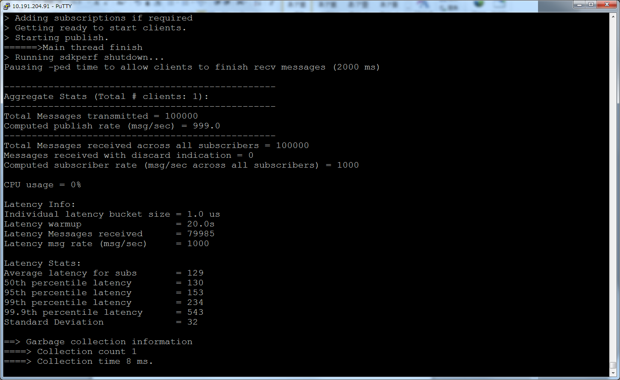

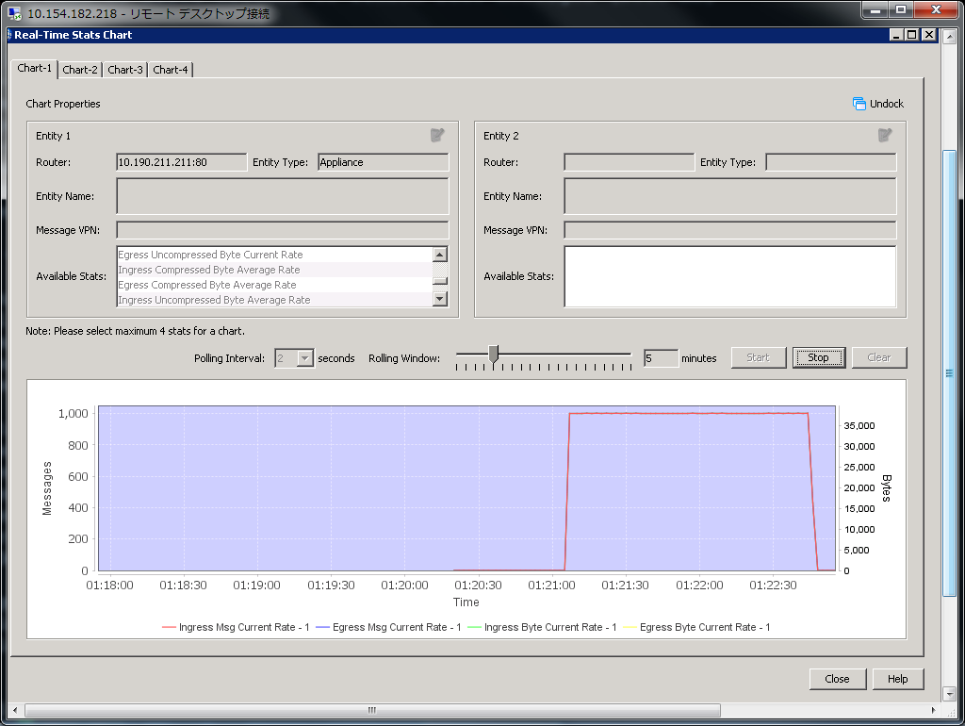

Direct Messaging - 1000 msgs/sec – 5０ bytes message size

./sdkperf_java.sh -cip=10.191.247.245 -ptl=test -mn=100000 -mr=1000 -l -lat -lwu=20 -cu=nomura-du@nomura -cp=password -msa=50 -psm –q

./sdkperf_java.sh -cip=10.191.247.245 -stl=test -l -cu=nomura-du@nomura -cp=password –q

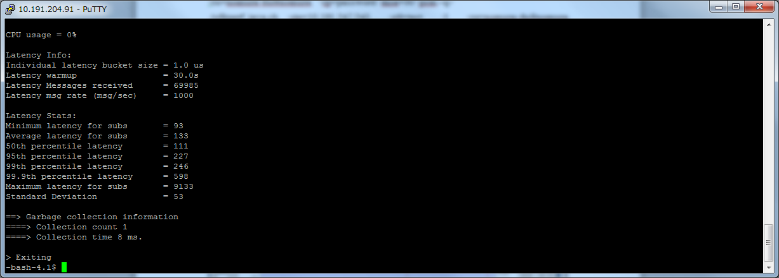

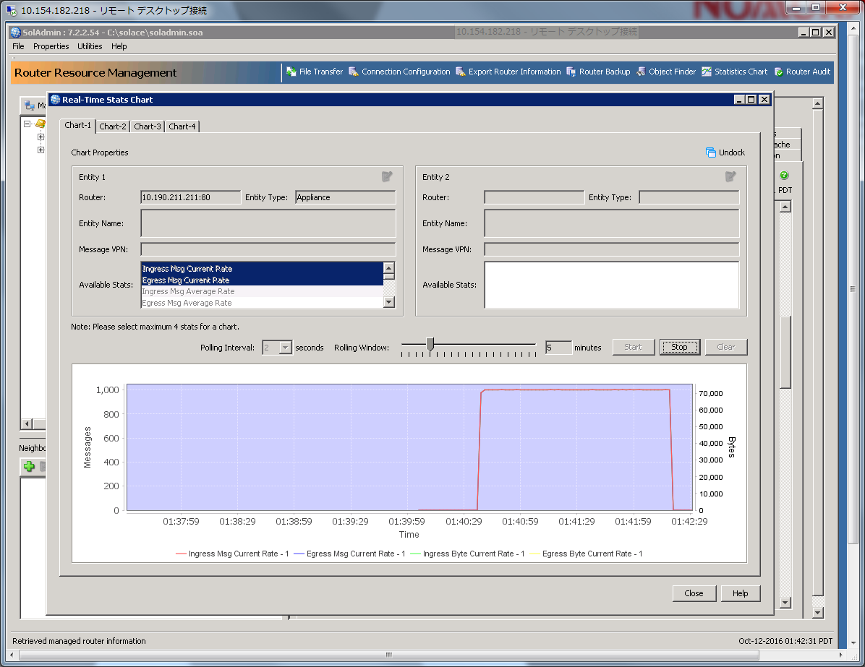

./sdkperf_java.sh -cip=10.191.247.245 -ptl=test -mn=100000 -mr=1000 -l -lat -lwu=20 -cu=nomura-du@nomura -cp=password -msa=100 -psm -q

./sdkperf_java.sh -cip=10.191.247.245 -stl=test -l -cu=nomura-du@nomura -cp=password –q

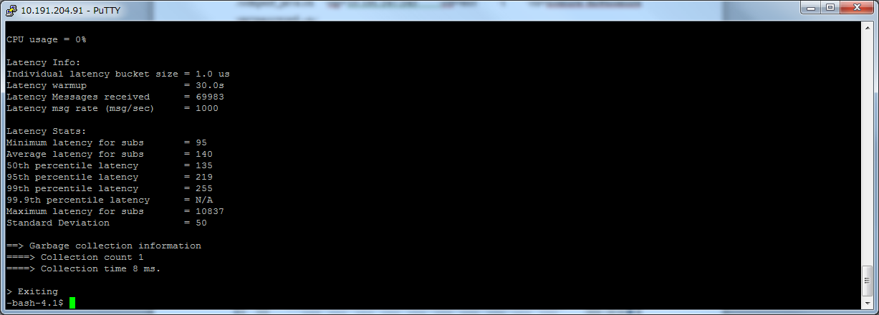

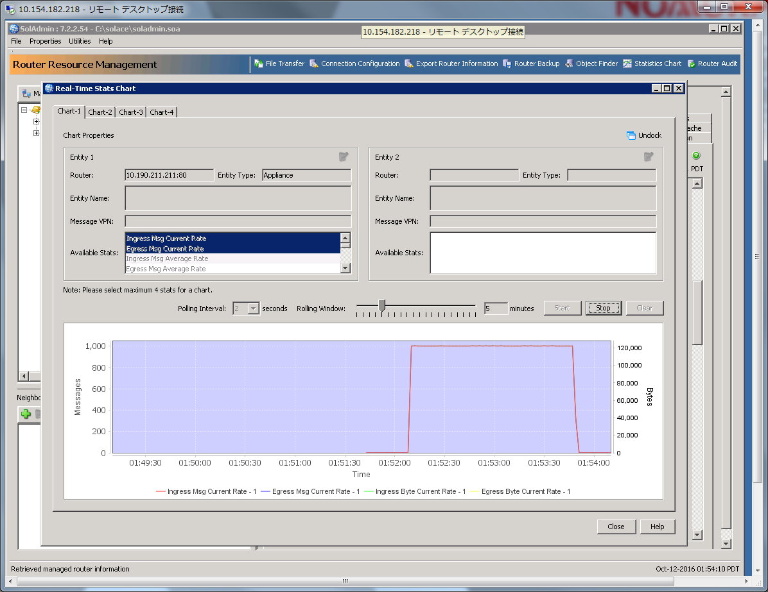

./sdkperf_java.sh -cip=10.191.247.245 -ptl=test -mn=100000 -mr=1000 -l -lat -lwu=20 -cu=nomura-du@nomura -cp=password -msa=500 -psm -q

./sdkperf_java.sh -cip=10.191.247.245 -stl=test -l -cu=nomura-du@nomura -cp=password –q

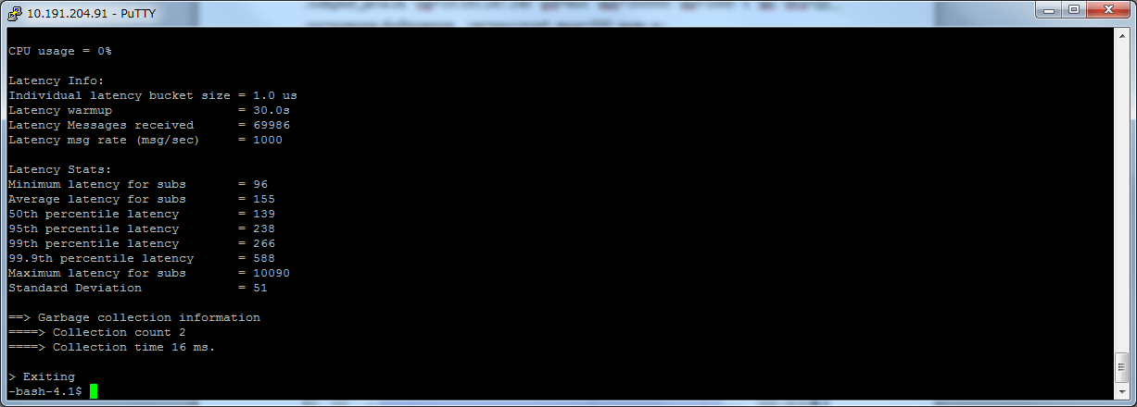

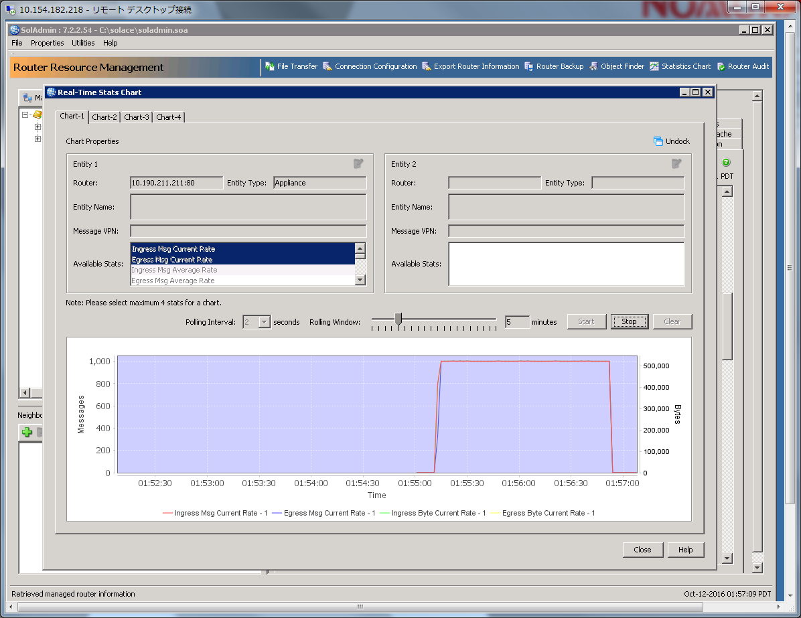

./sdkperf_java.sh -cip=10.191.247.245 -ptl=test -mn=100000 -mr=1000 -l -lat -lwu=20 -cu=nomura-du@nomura -cp=password -msa=1000 -psm -q

./sdkperf_java.sh -cip=10.191.247.245 -stl=test -l -cu=nomura-du@nomura -cp=password –q

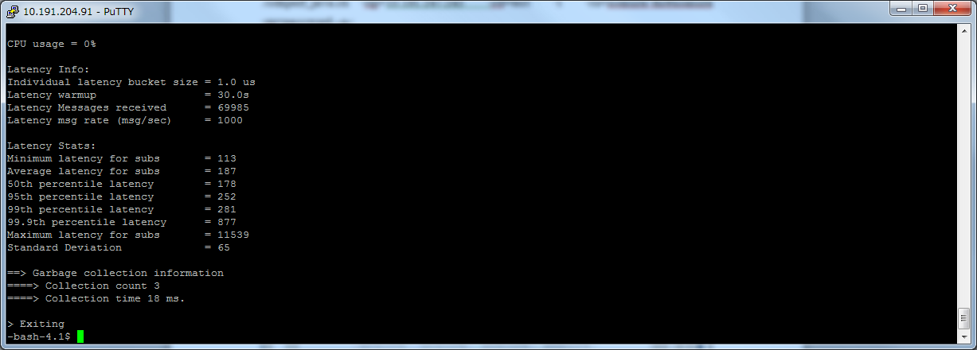

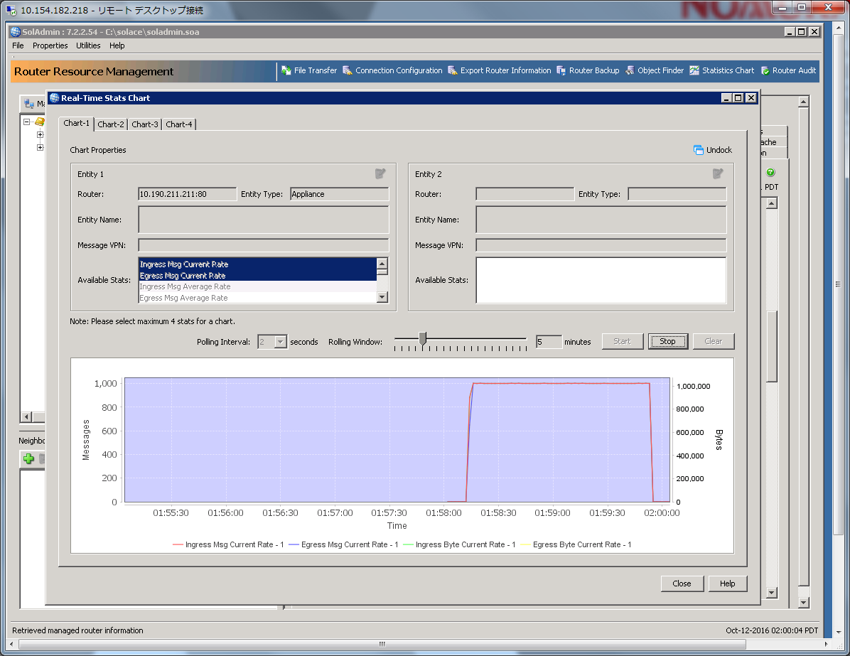

./sdkperf_java.sh -cip=10.191.247.245 -ptl=test -mn=100000 -mr=1000 -l -lat -lwu=20 -cu=nomura-du@nomura -cp=password -msa=2000 -psm -q

./sdkperf_java.sh -cip=10.191.247.245 -stl=test -l -cu=nomura-du@nomura -cp=password –q

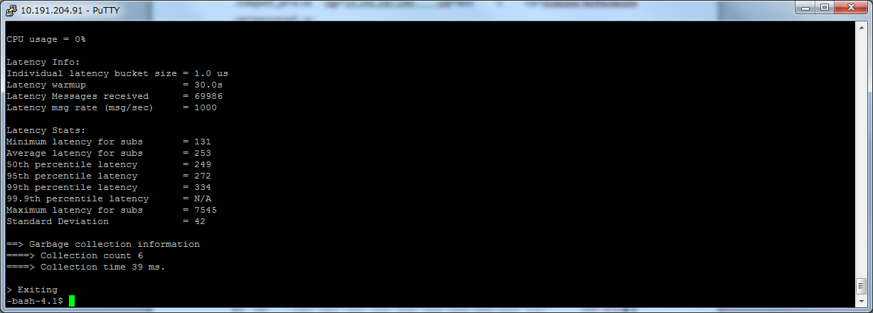

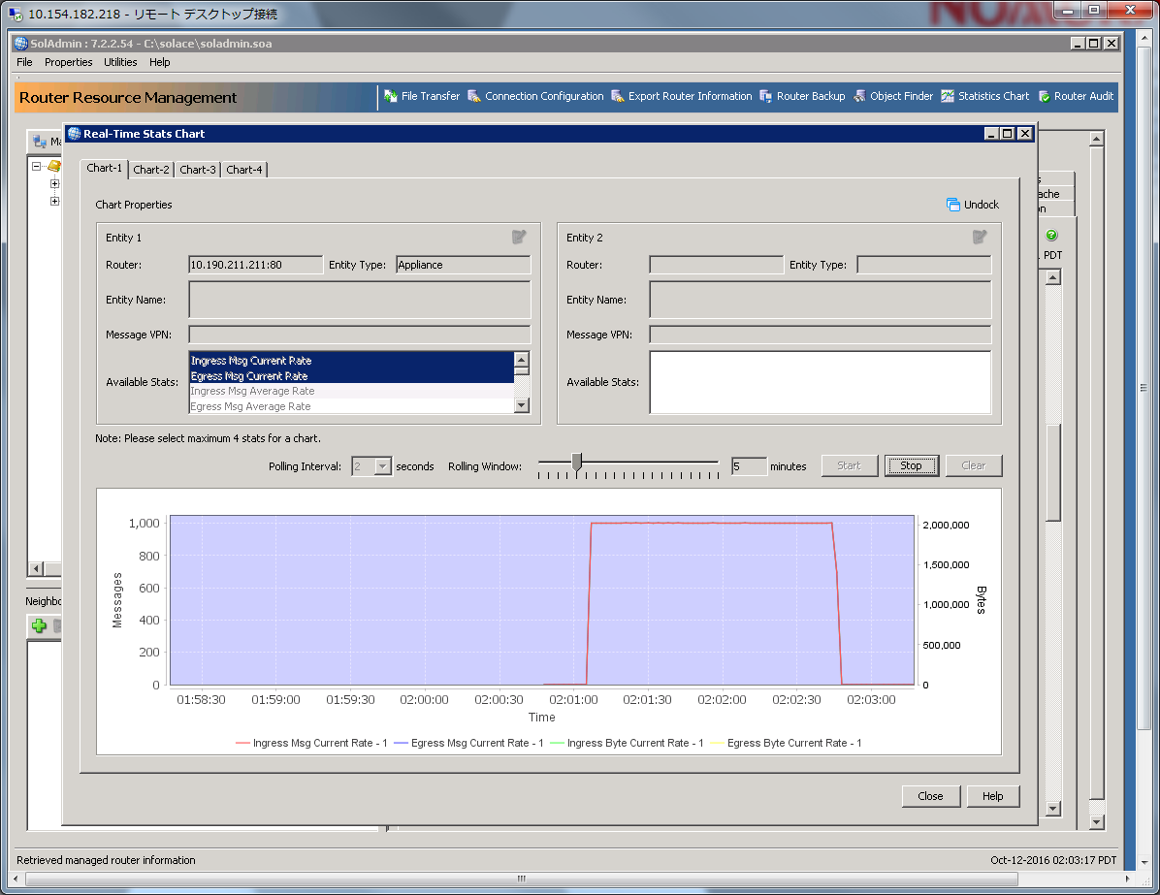

./sdkperf_java.sh -cip=10.191.247.245 -ptl=test -mn=100000 -mr=1000 -l -lat -lwu=20 -cu=nomura-du@nomura -cp=password -msa=5000 -psm -q

./sdkperf_java.sh -cip=10.191.247.245 -stl=test -l -cu=nomura-du@nomura -cp=password –q

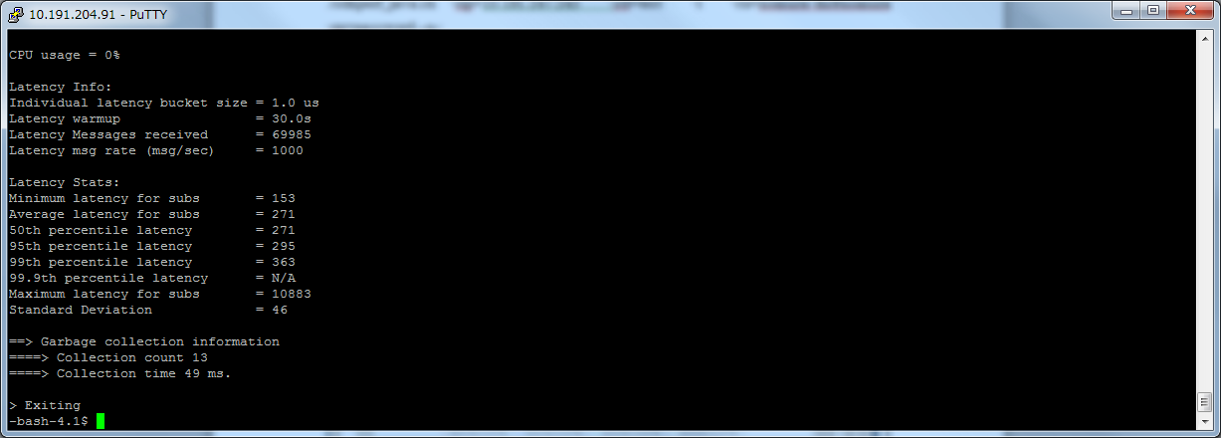

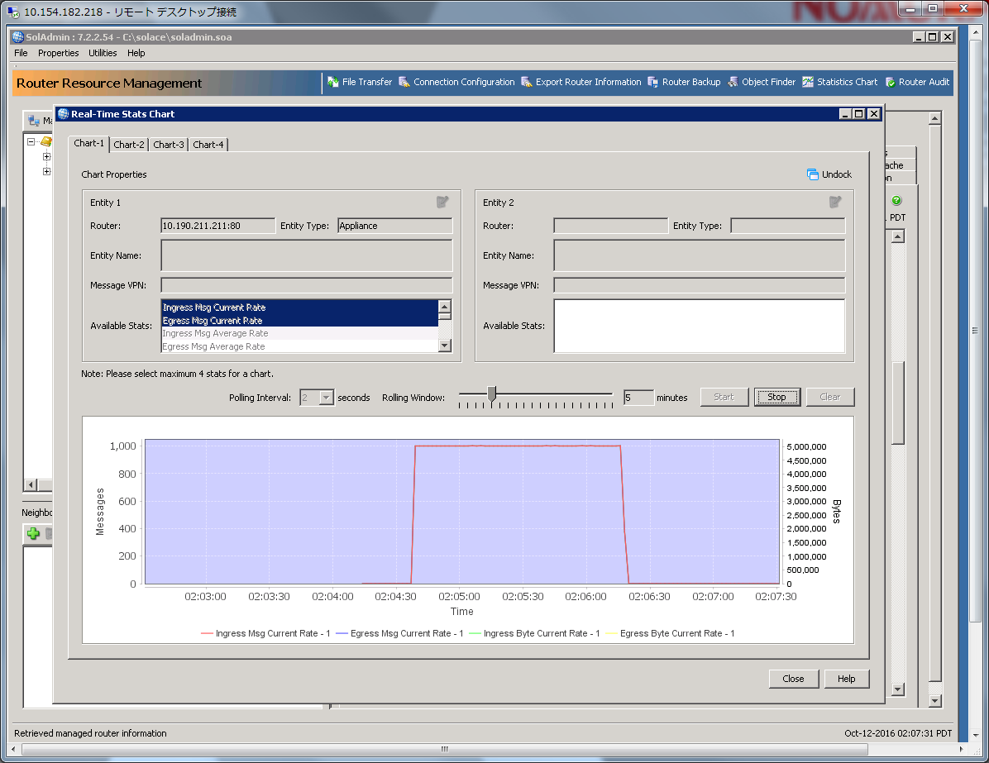

Guaranteed messaging tests

./sdkperf_java.sh -cip=10.191.247.245 -ptl=test -mn=100000 -mr=1000 -l -lat -lwu=20 -cu=nomura-gu@nomura -cp=password -psm -q -mt=persistent

./sdkperf_java.sh -cip=10.191.247.245 -sql=testQ -l -cu=nomura-gu@nomura -cp=password –q

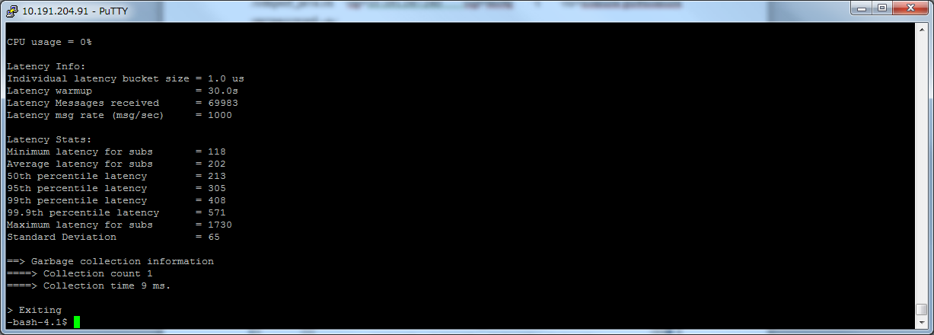

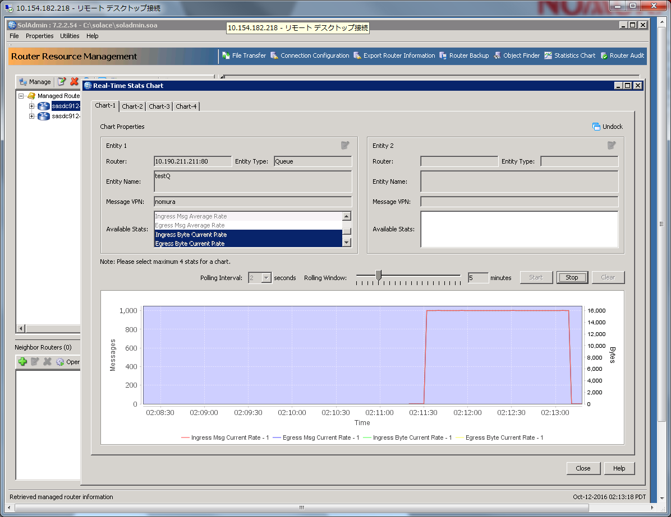

./sdkperf_java.sh -cip=10.191.247.245 -ptl=test -mn=100000 -mr=1000 -l -lat -lwu=20 -cu=nomura-gu@nomura -cp=password -psm -q -mt=persistent -msa=50

./sdkperf_java.sh -cip=10.191.247.245 -sql=testQ -l -cu=nomura-gu@nomura -cp=password –q

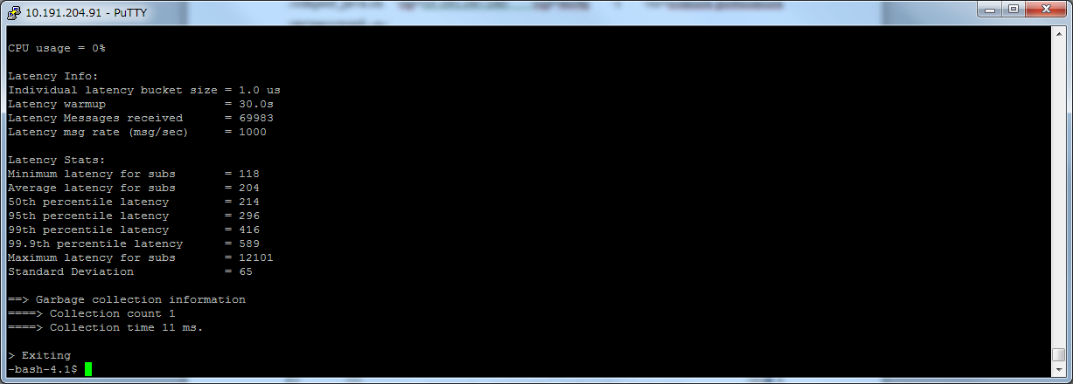

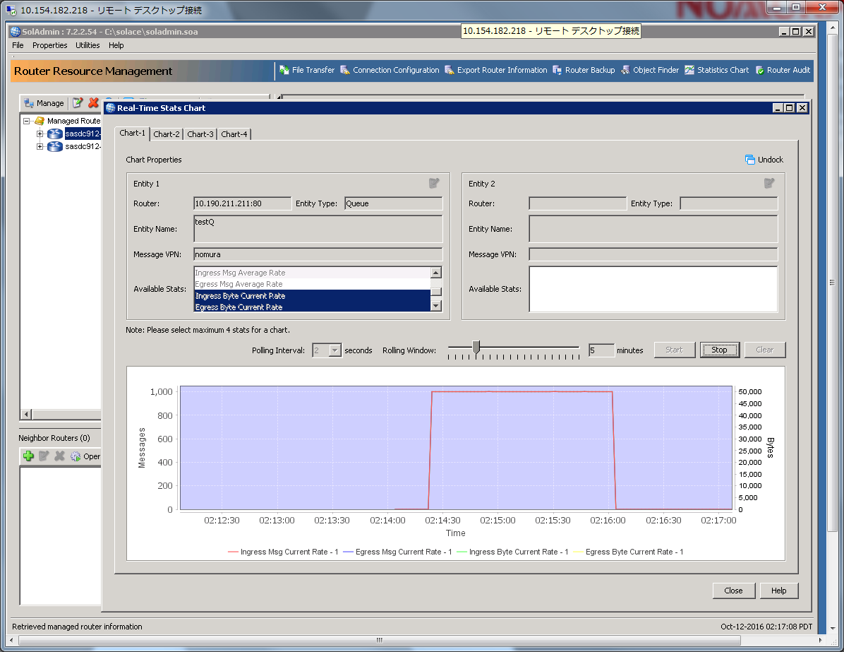

./sdkperf_java.sh -cip=10.191.247.245 -ptl=test -mn=100000 -mr=1000 -l -lat -lwu=20 -cu=nomura-gu@nomura -cp=password -psm -q -mt=persistent -msa=100

./sdkperf_java.sh -cip=10.191.247.245 -sql=testQ -l -cu=nomura-gu@nomura -cp=password –q

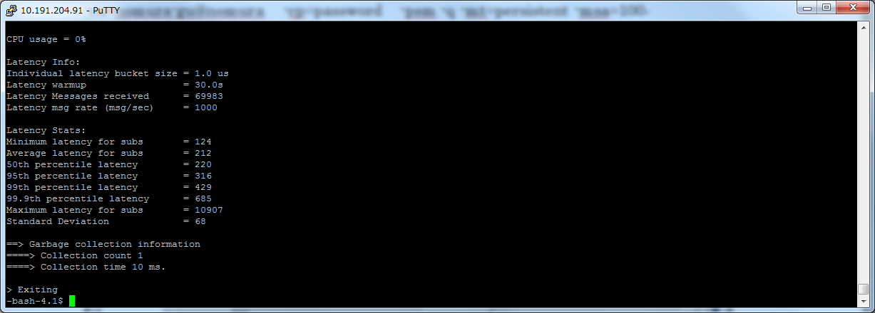

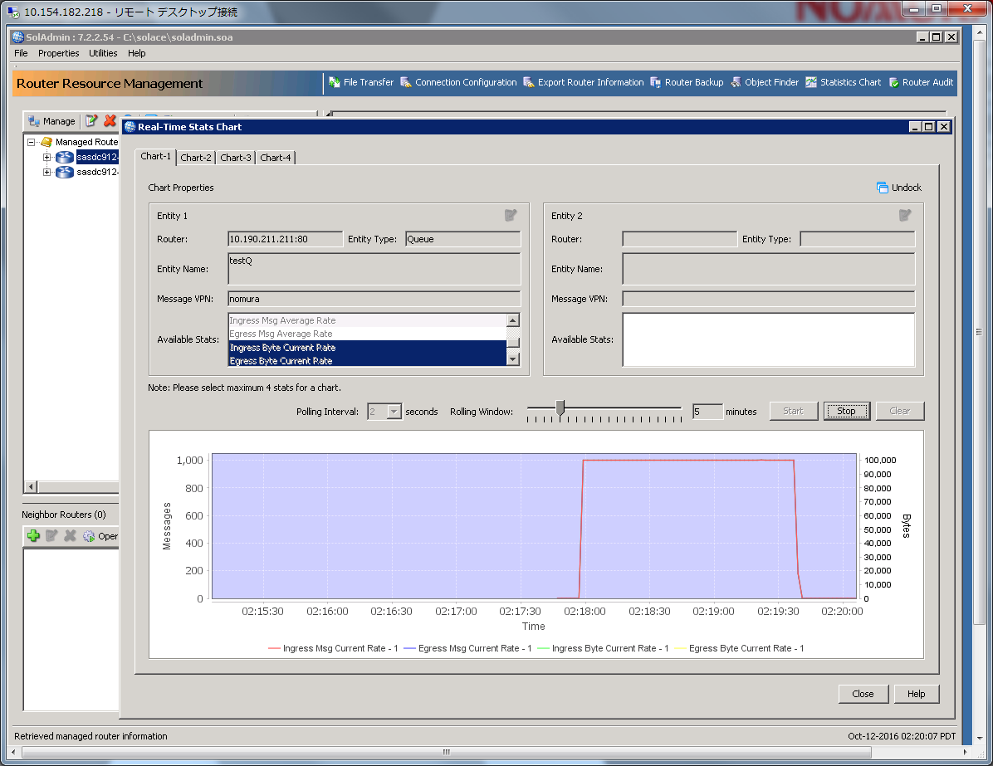

./sdkperf_java.sh -cip=10.191.247.245 -ptl=test -mn=100000 -mr=1000 -l -lat -lwu=20 -cu=nomura-gu@nomura -cp=password -psm -q -mt=persistent -msa=500

./sdkperf_java.sh -cip=10.191.247.245 -sql=testQ -l -cu=nomura-gu@nomura -cp=password –q

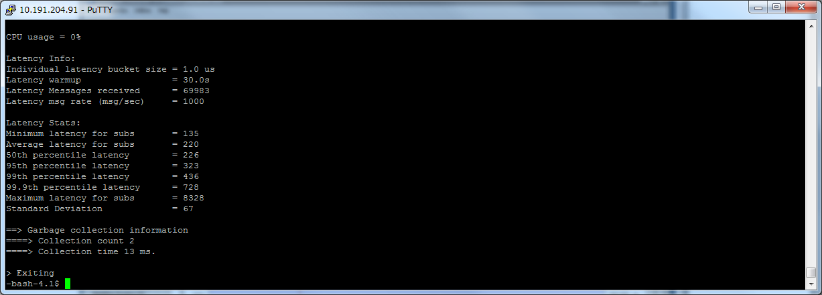

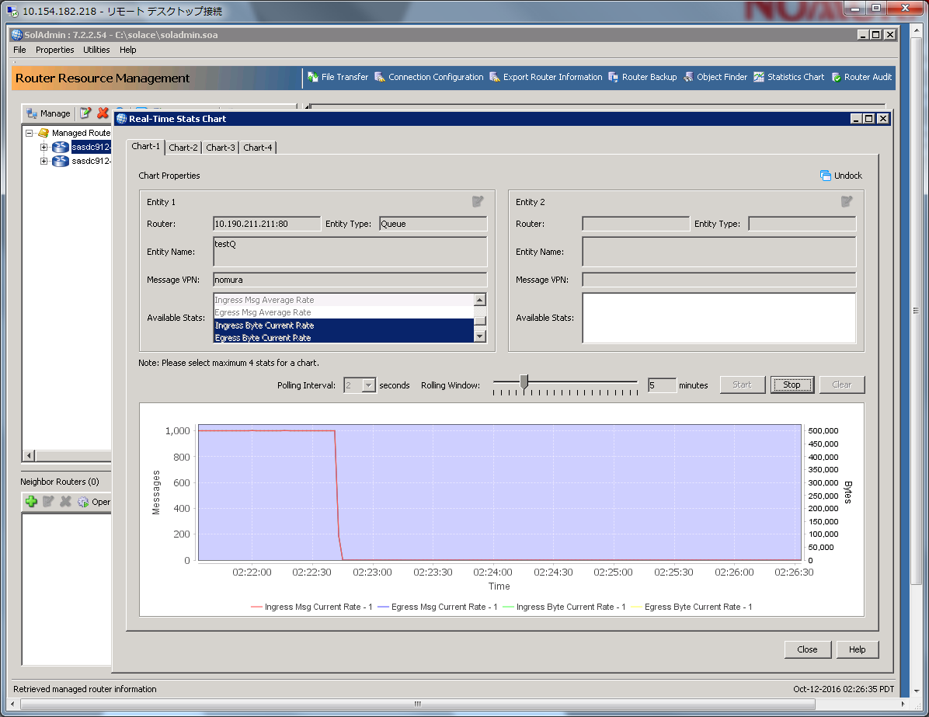

./sdkperf_java.sh -cip=10.191.247.245 -ptl=test -mn=100000 -mr=1000 -l -lat -lwu=20 -cu=nomura-gu@nomura -cp=password -psm -q -mt=persistent -msa=1000

./sdkperf_java.sh -cip=10.191.247.245 -sql=testQ -l -cu=nomura-gu@nomura -cp=password –q

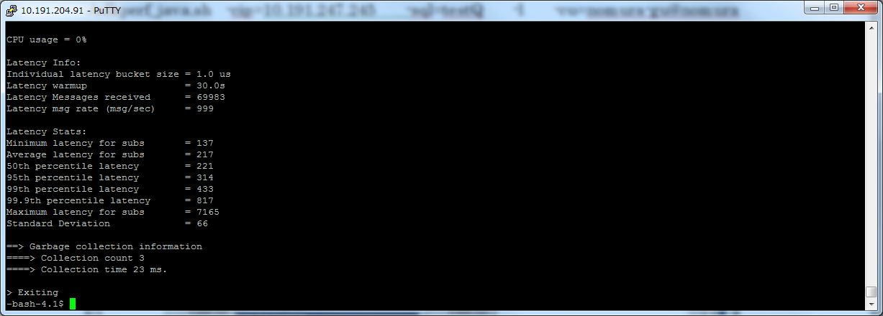

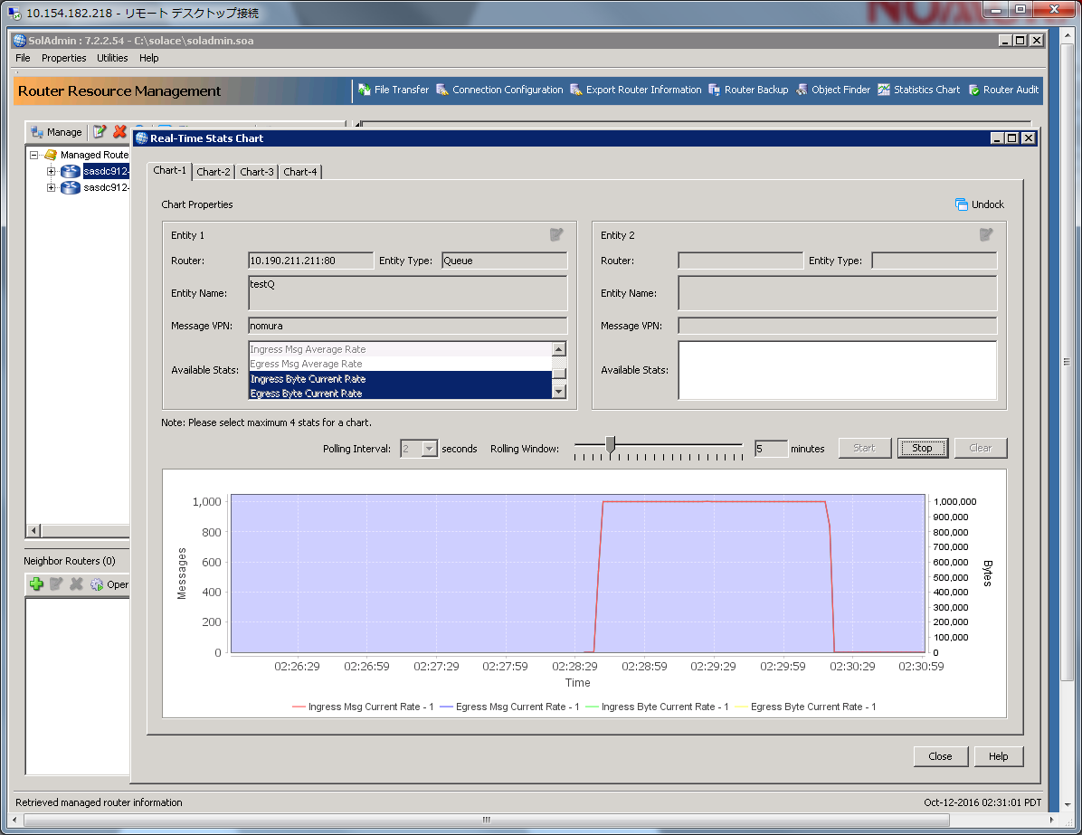

./sdkperf_java.sh -cip=10.191.247.245 -ptl=test -mn=100000 -mr=1000 -l -lat -lwu=20 -cu=nomura-gu@nomura -cp=password -psm -q -mt=persistent -msa=2000

./sdkperf_java.sh -cip=10.191.247.245 -sql=testQ -l -cu=nomura-gu@nomura -cp=password –q

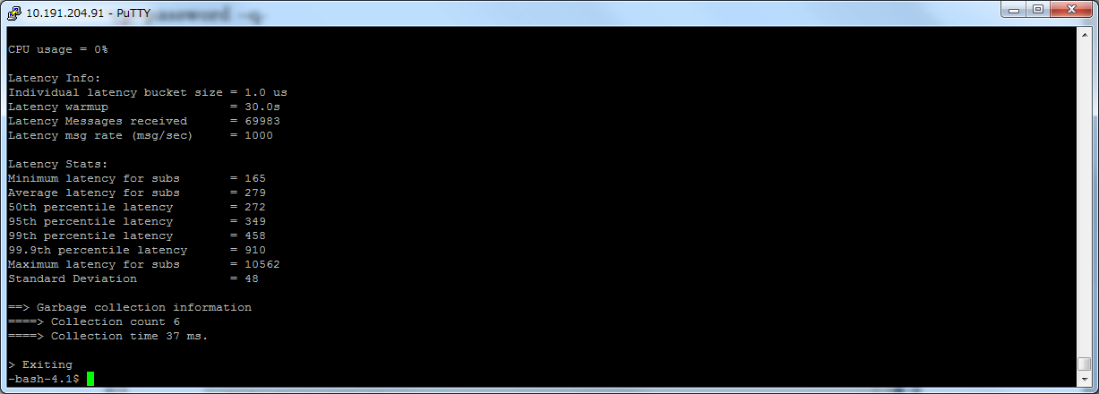

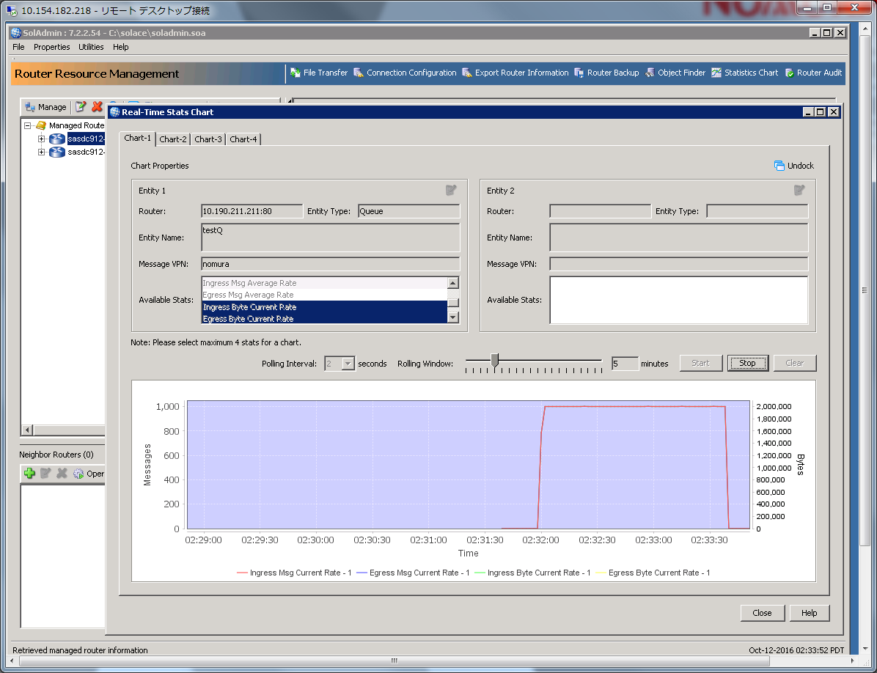

./sdkperf_java.sh -cip=10.191.247.245 -ptl=test -mn=100000 -mr=1000 -l -lat -lwu=20 -cu=nomura-gu@nomura -cp=password -psm -q -mt=persistent -msa=5000

./sdkperf_java.sh -cip=10.191.247.245 -sql=testQ -l -cu=nomura-gu@nomura -cp=password -q

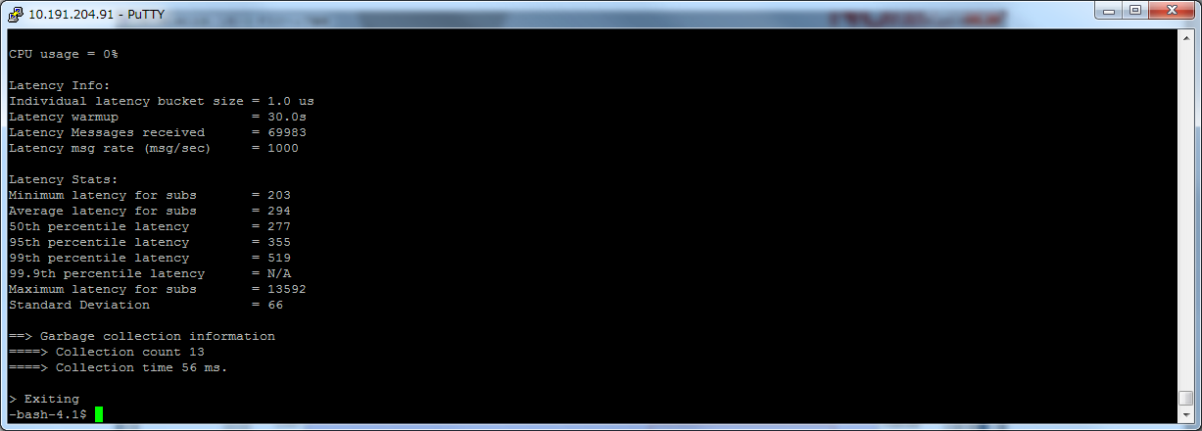

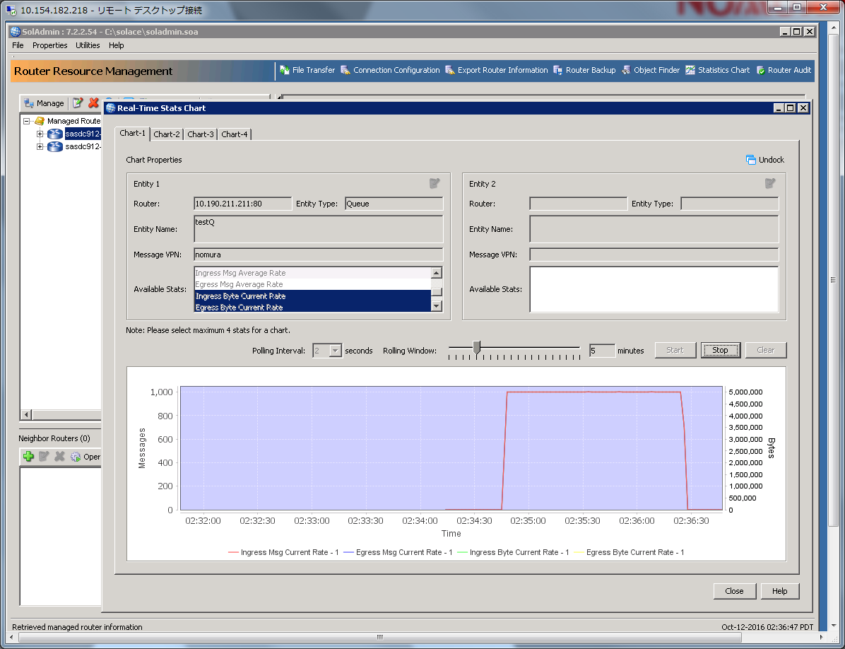

Throughput

１：１

./pub__direct_througput.sh 15 ５0

./sub__direct_througput.sh 15

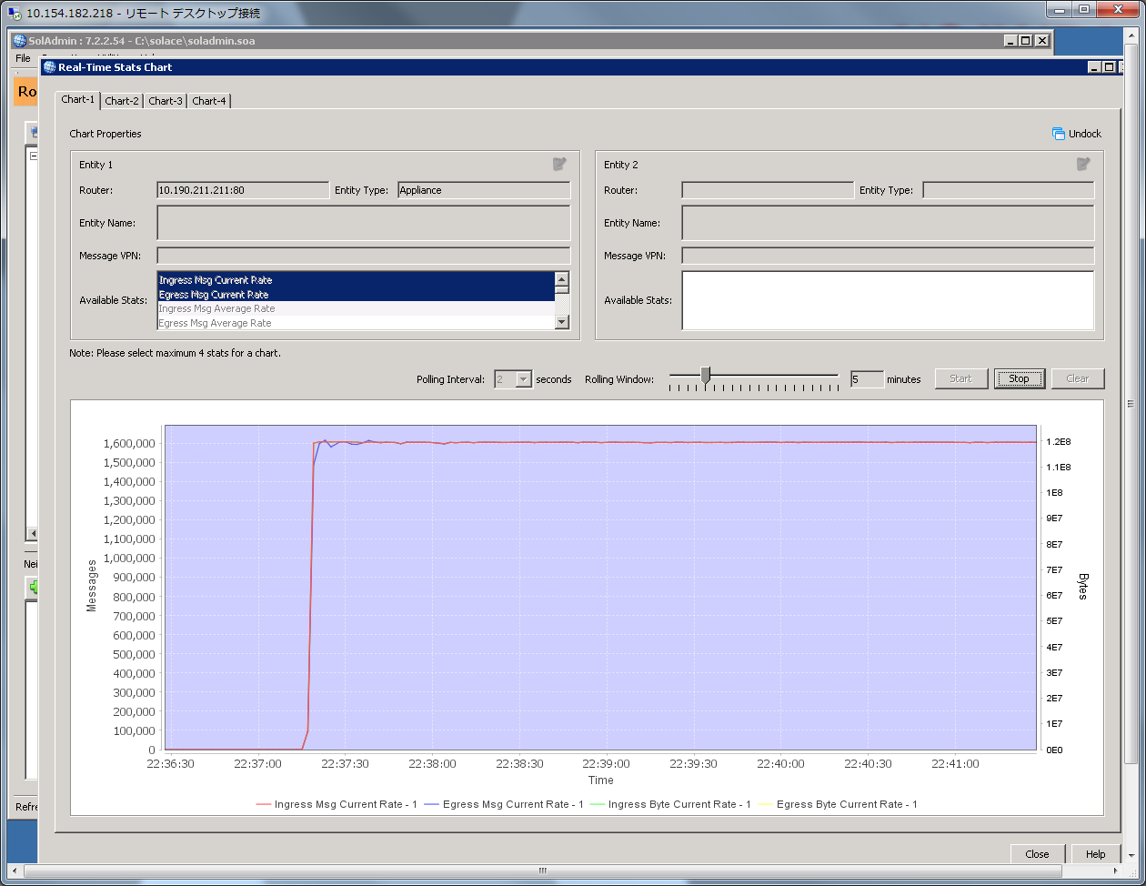

./pub__direct_througput.sh 15 100

./sub__direct_througput.sh 15

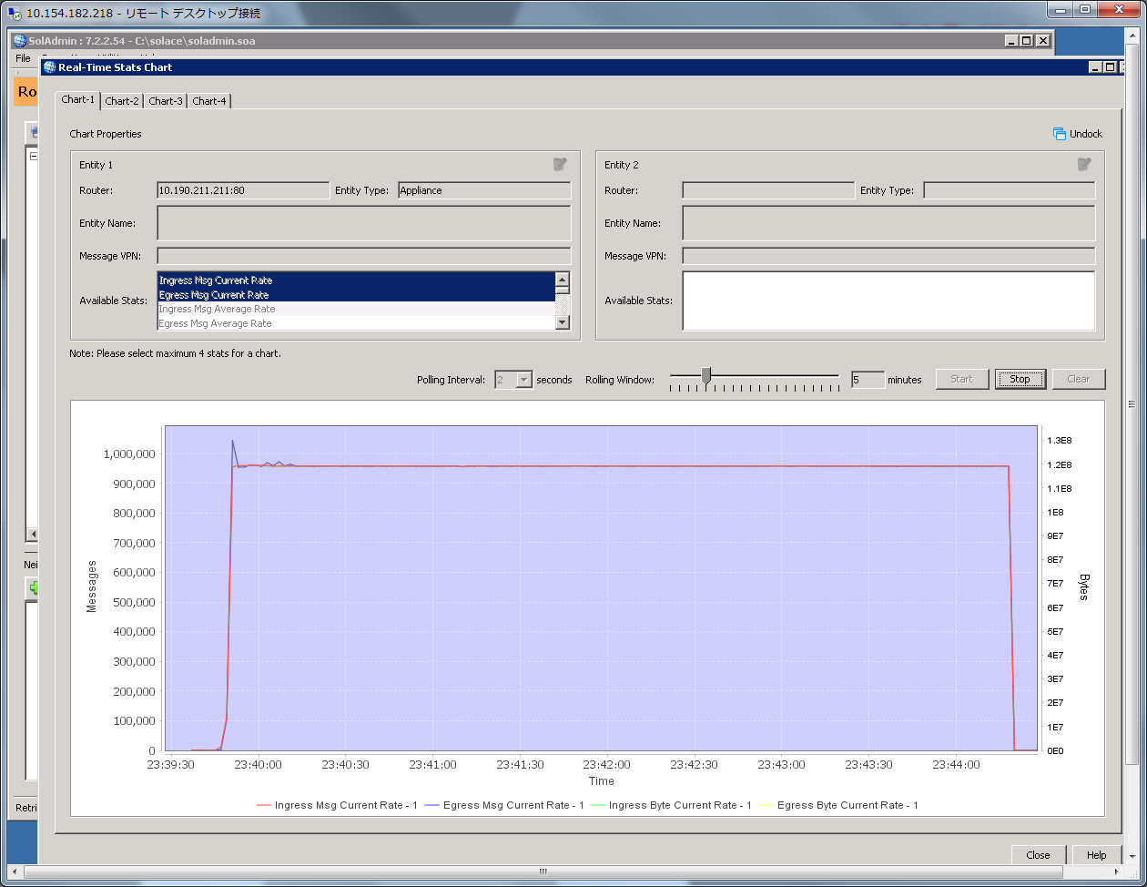

./pub__direct_througput.sh 15 500

./sub__direct_througput.sh 15

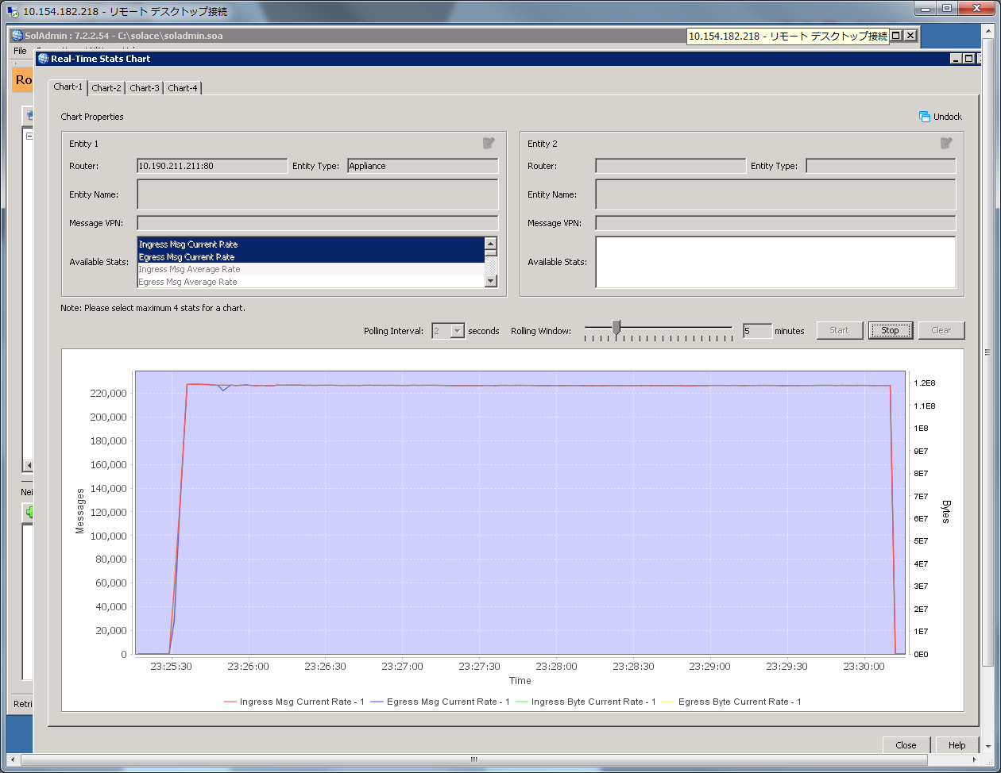

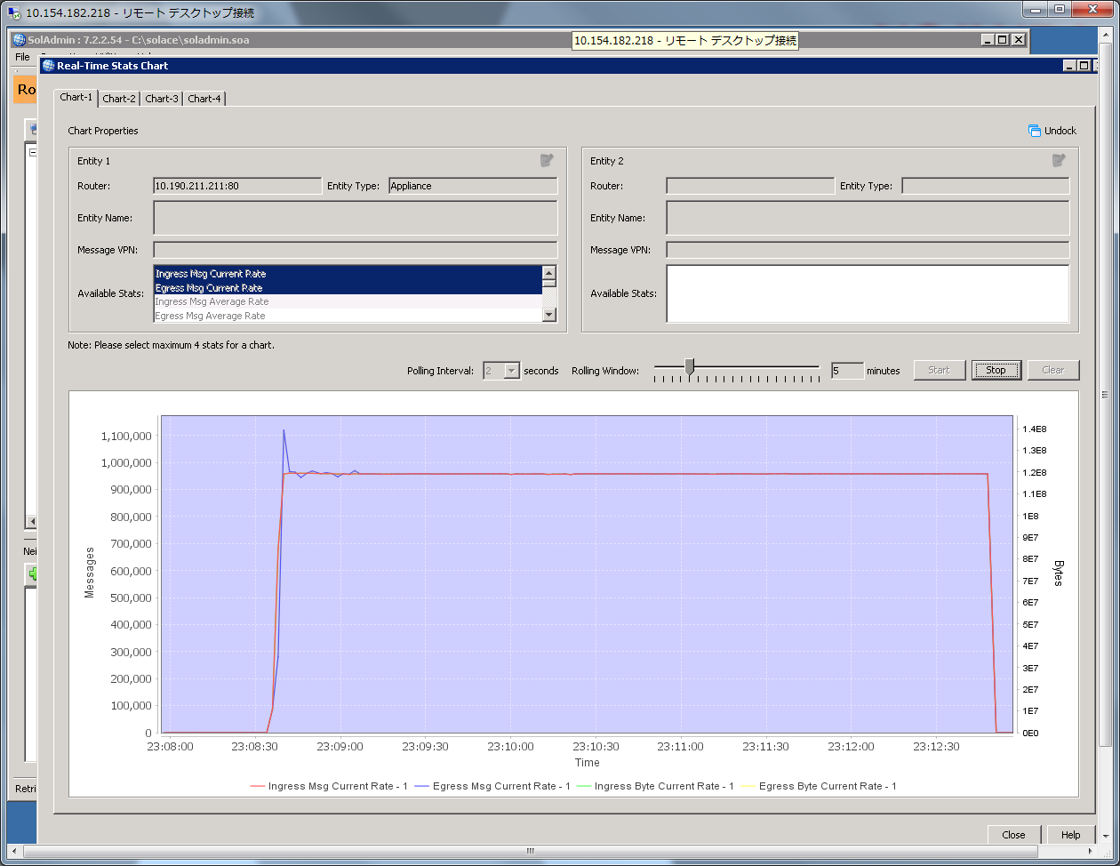

./pub__direct_througput.sh 15 1000

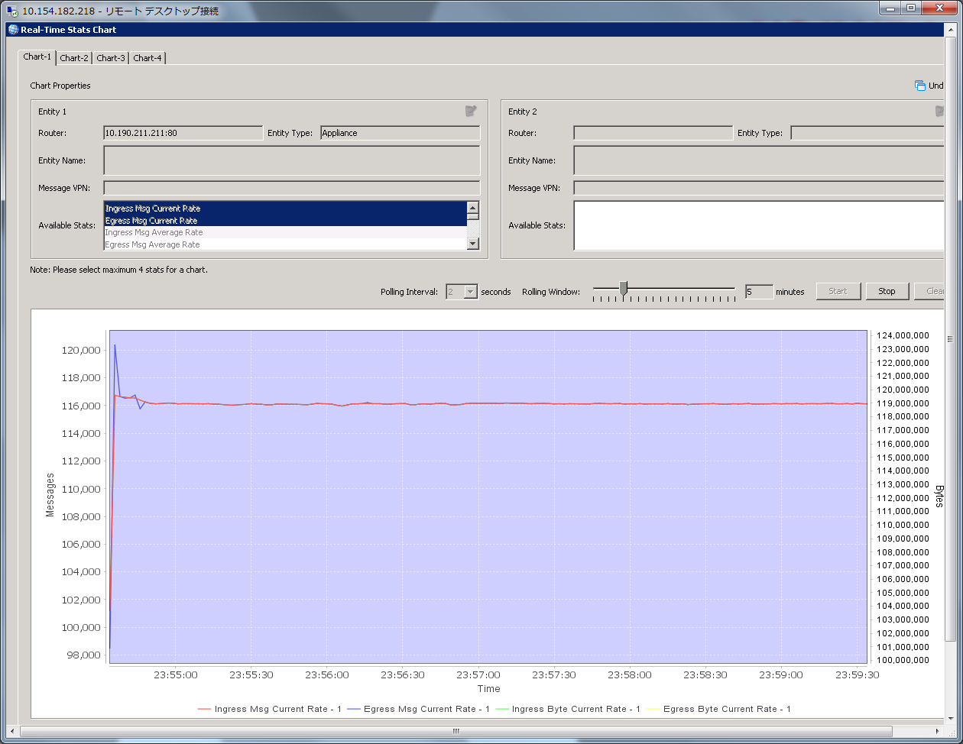

./pub__direct_througput.sh 15 2000

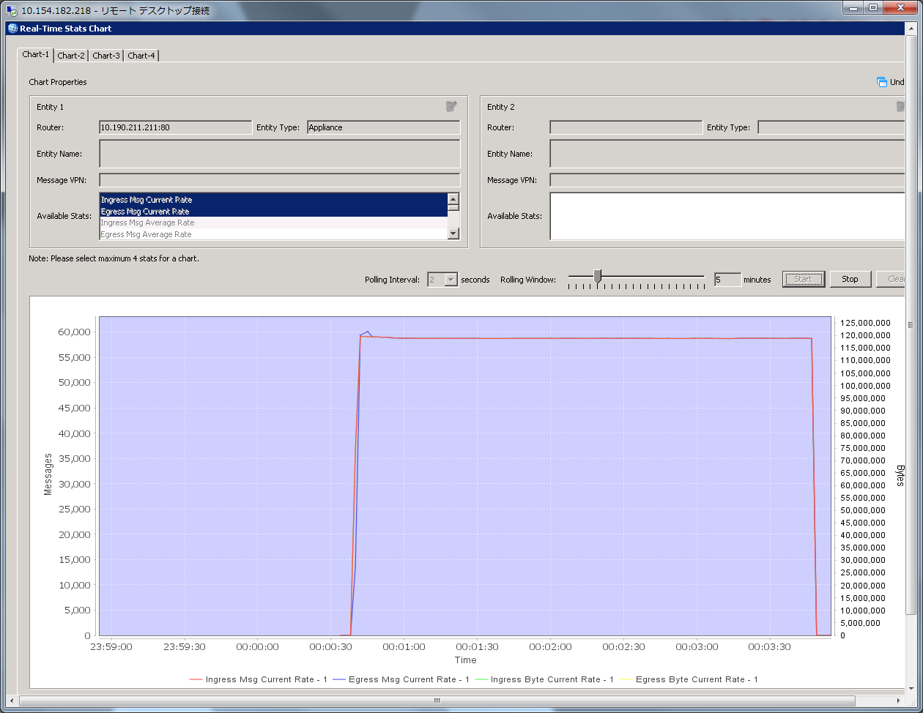

./pub__direct_througput.sh 15 5000

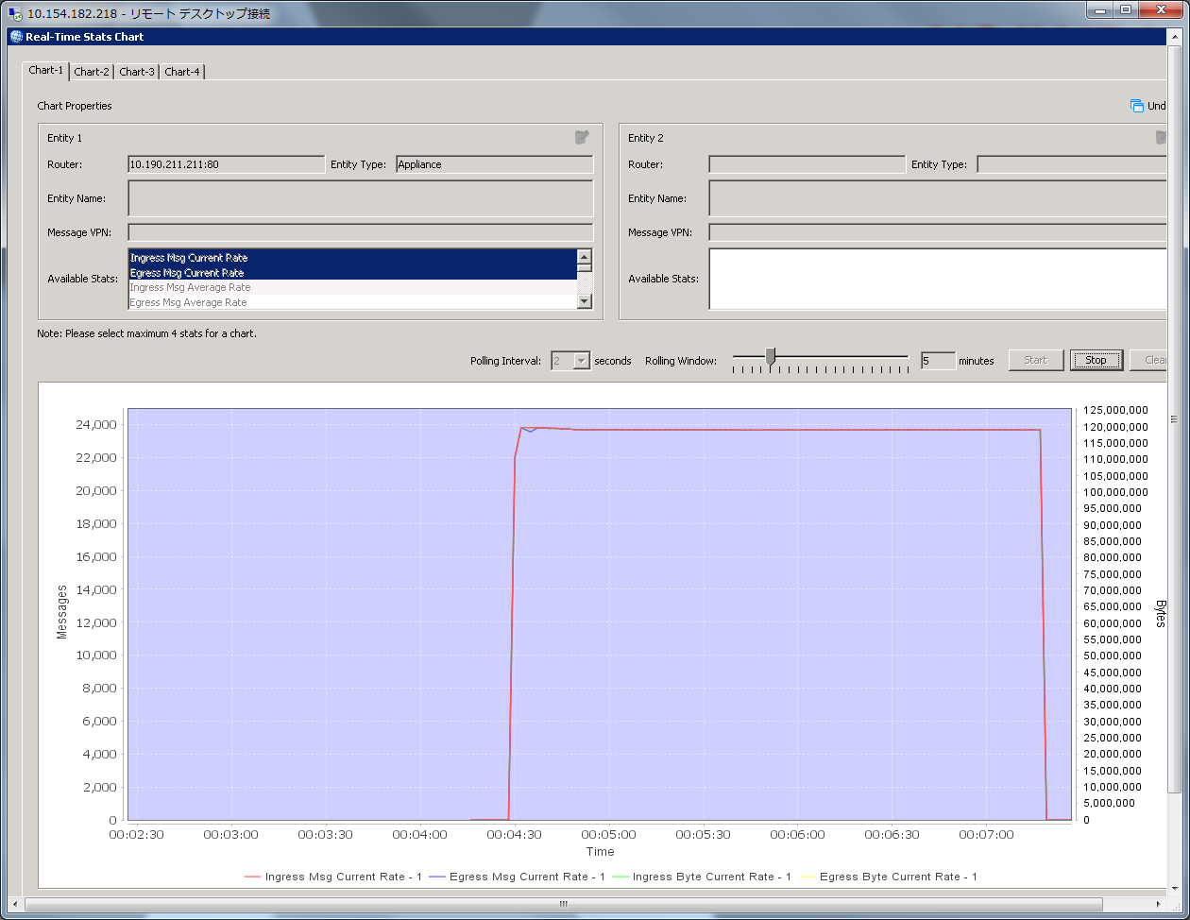

Single Publisher and Single Subscriber

./pub__direct_througput.sh 1 1000

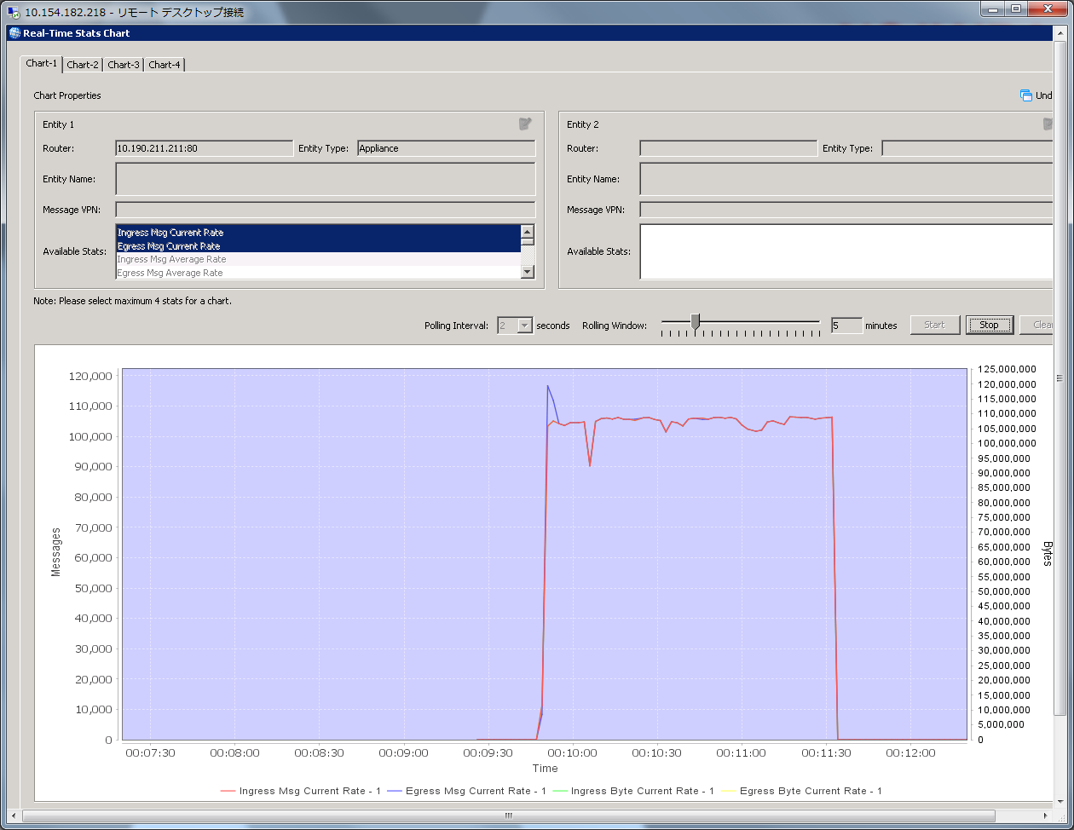

１；１０@ 1kb

./pub_fo_one_to_many_direct_througput.sh 15 1000;

./sub_fo_one_to_many_direct_througput.sh 15

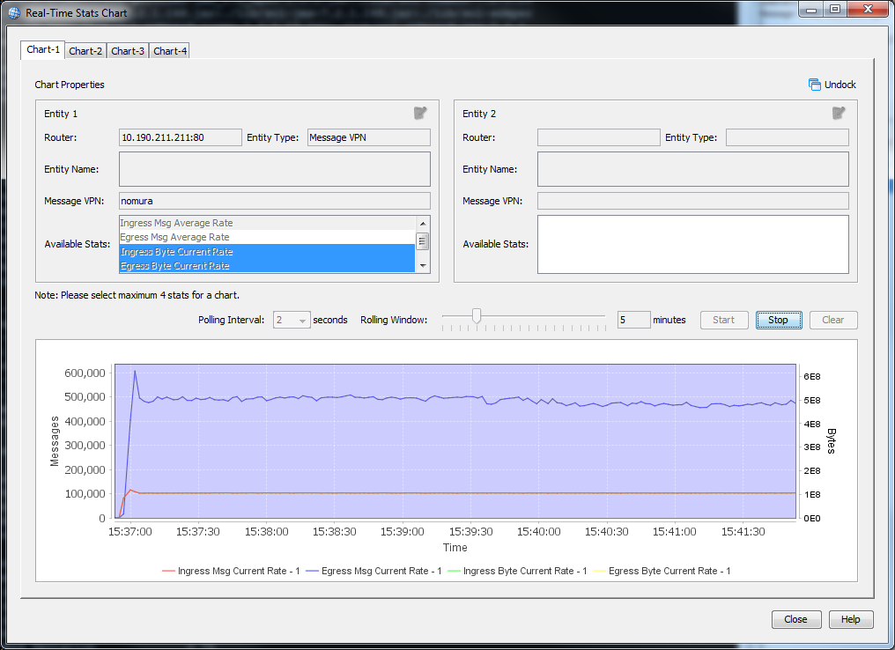

Latency stats

./sdkperf_java.sh -cip=10.191.247.245 -ptl=test/fo/probe -cu=nomura-du@nomura -cp=password -l -mn=10000 -mr=100 –msa=1000

./sdkperf_java.sh -cip=10.191.247.245 -stl=test/fo/probe -cu=nomura-du@nomura -cp=password -l -lat -lb=4096 -lwu=20 –q

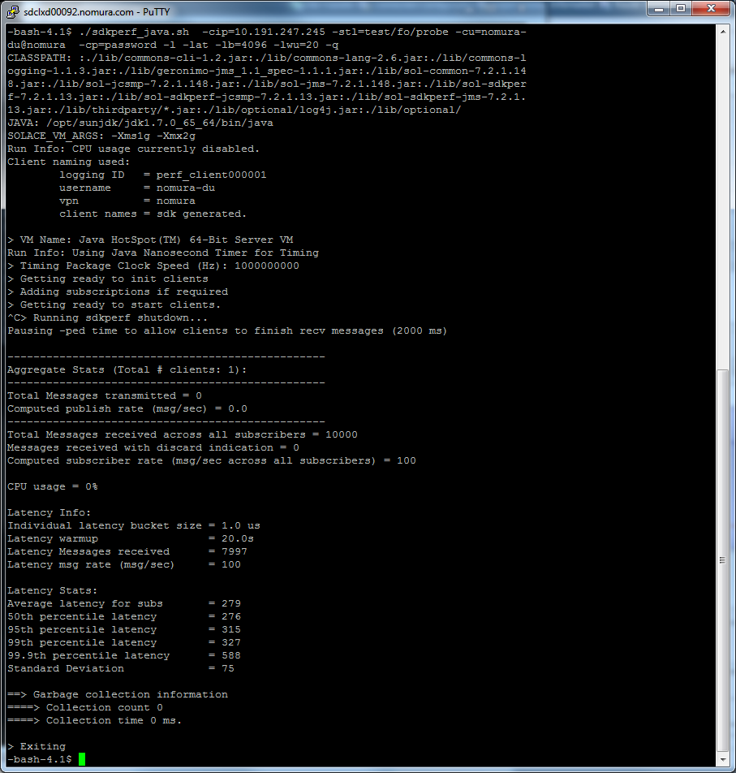

./pub_fo_one_to_many_direct_througput.sh 15 2000;

./sub_fo_one_to_many_direct_througput.sh 15

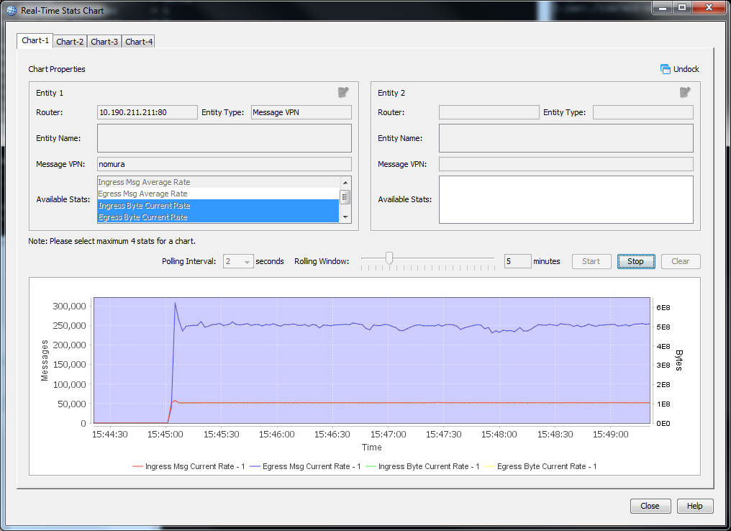

Latency

./sdkperf_java.sh -cip=10.191.247.245 -ptl=test/fo/probe -cu=nomura-du@nomura -cp=password -l -mn=10000 -mr=100 -msa=2000

./sdkperf_java.sh -cip=10.191.247.245 -stl=test/fo/probe -cu=nomura-du@nomura -cp=password -l -lat -lb=4096 -lwu=20 –q

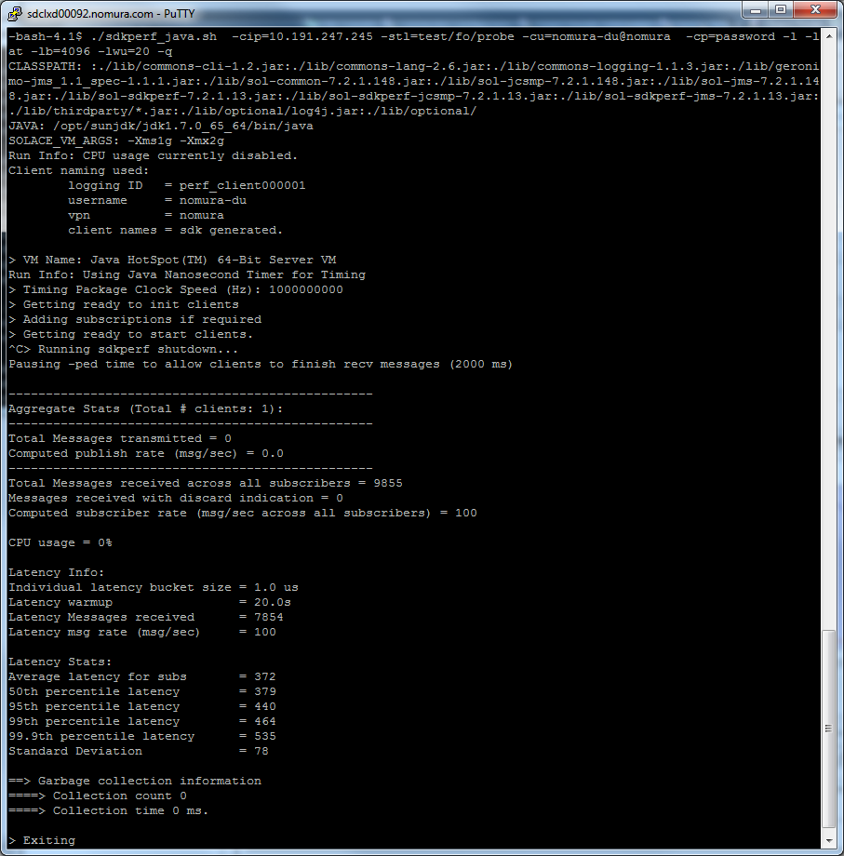

./pub_fo_one_to_many_direct_througput.sh 15 5000;

./sub_fo_one_to_many_direct_througput.sh 15

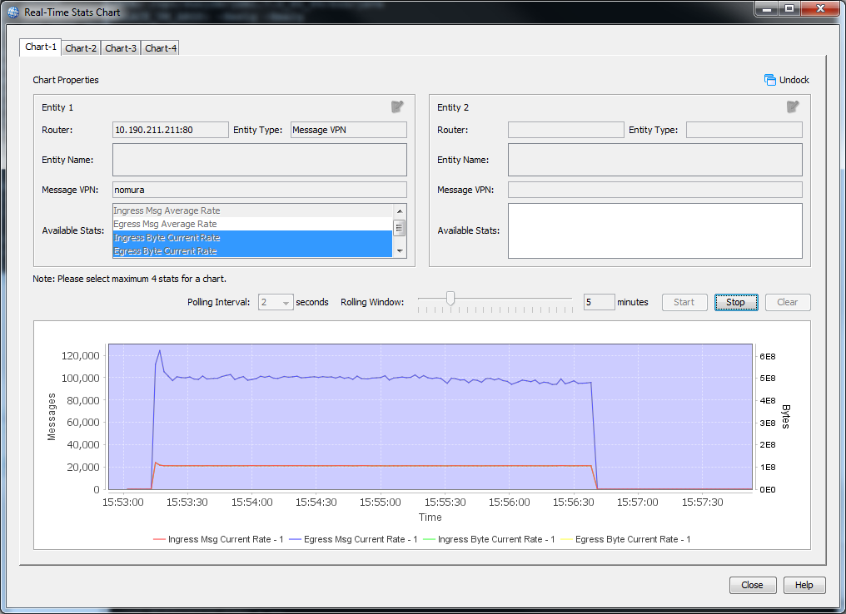

Latency

./sdkperf_java.sh -cip=10.191.247.245 -ptl=test/fo/probe -cu=nomura-du@nomura -cp=password -l -mn=10000 -mr=100 -msa=5000

./sdkperf_java.sh -cip=10.191.247.245 -stl=test/fo/probe -cu=nomura-du@nomura -cp=password -l -lat -lb=4096 -lwu=20 -q

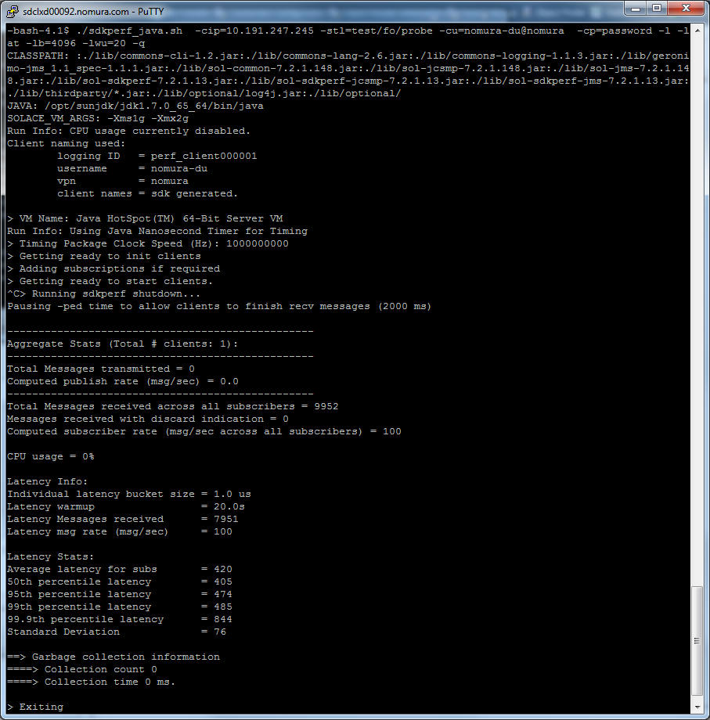

Many to 1 direct Throughput

./pub_fo_many_to_one_direct_througput.sh 10 1000 14

./sub_fo_many_to_one_direct_througput.sh 14

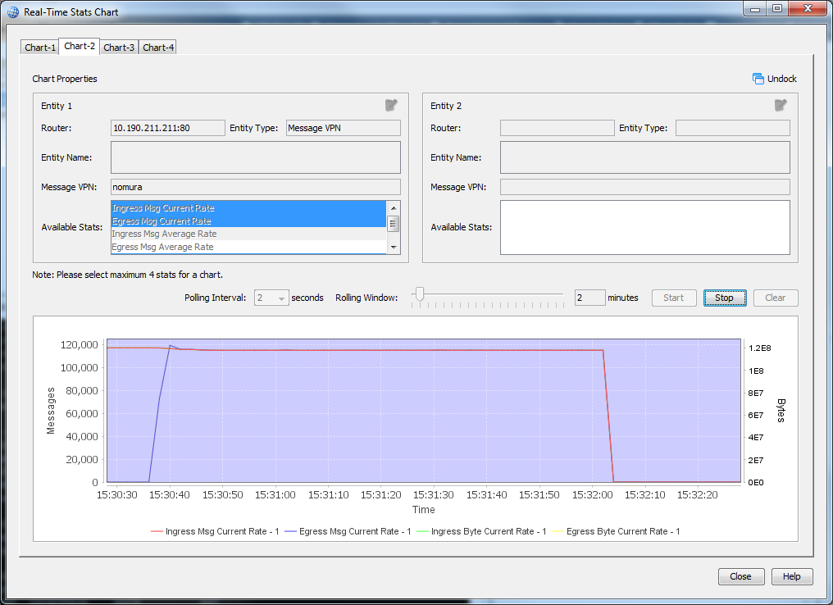

./pub_fo_many_to_one_direct_througput.sh 10 2000 14

./sub_fo_many_to_one_direct_througput.sh 14

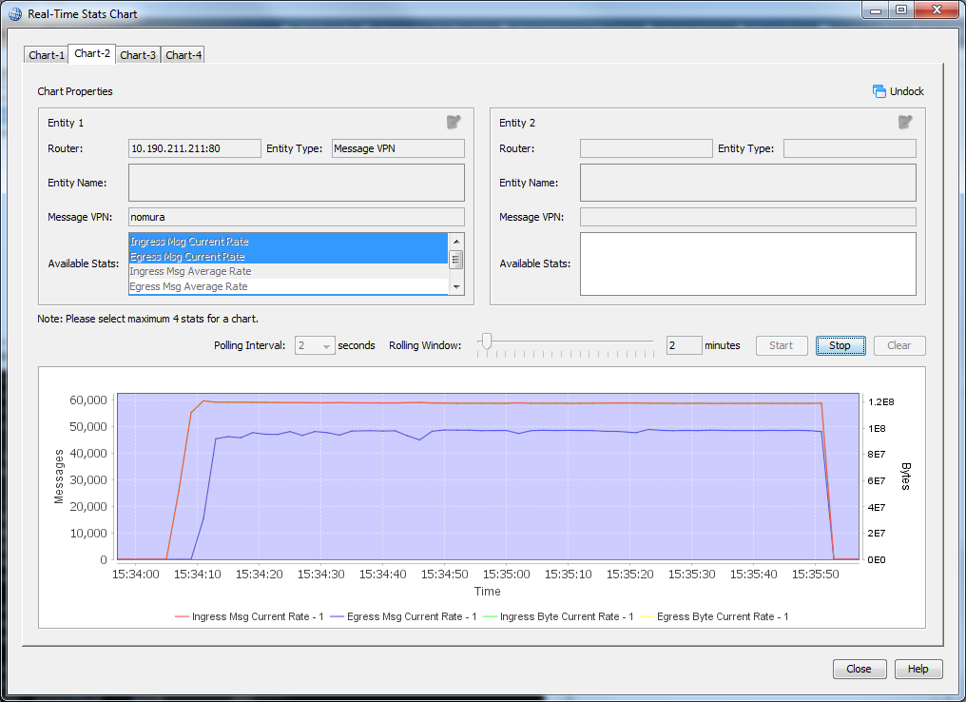

./pub_fo_many_to_one_direct_througput.sh 10 5000 14

./sub_fo_many_to_one_direct_througput.sh 14

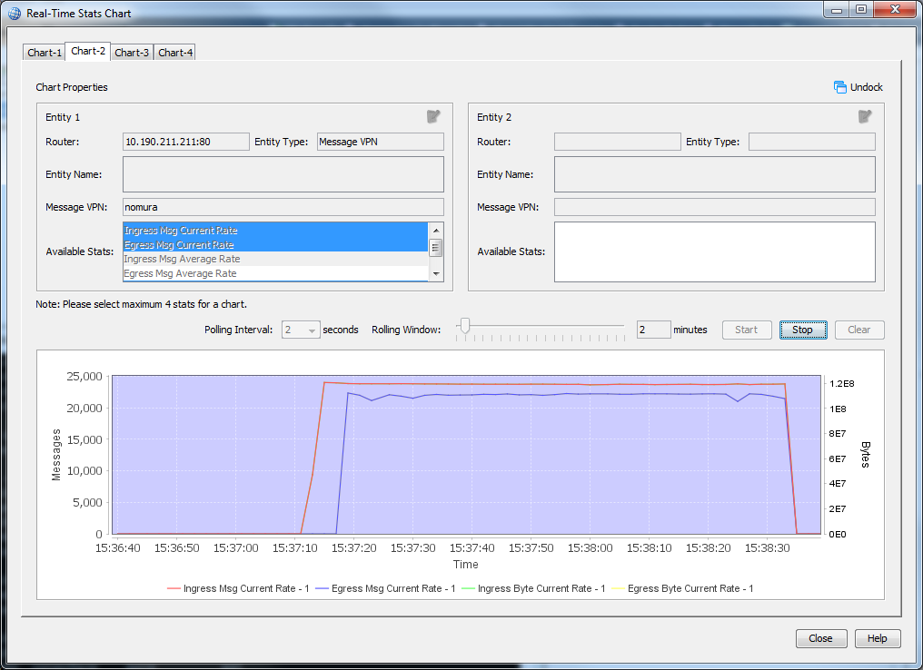

Guaranteed Message Throughput

./pub__gm_througput.sh 10 50 16500

./sub__gm__througput.sh 10

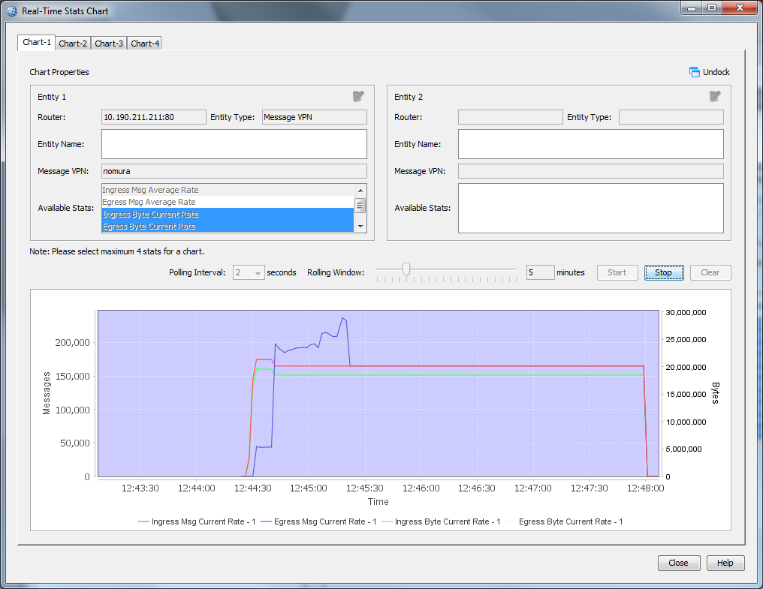

./pub__gm_througput.sh 10 100 16500

./sub__gm__througput.sh 10

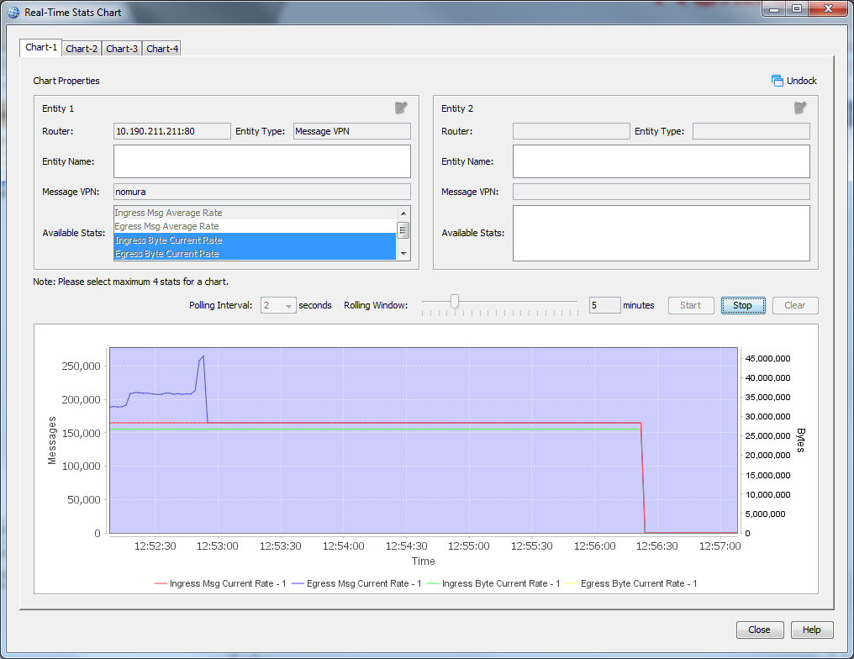

Latency Stats

./sdkperf_java.sh -cip=10.191.247.245 -ptl=test/gm/probe -cu=nomura-gu@nomura -cp=password -l -mn=10000 -mr=100 -mt=persistent -msa=100

./sdkperf_java.sh -cip=10.191.247.245 -stl=test/gm/probe -cu=nomura-gu@nomura -cp=password -l -lat -lb=4096 -lwu=20 -tte=1 –q

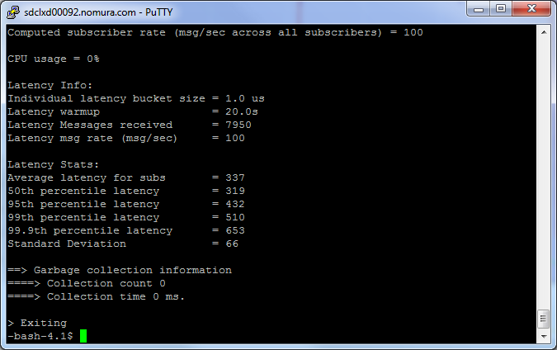

./pub__gm_througput.sh 10 1000 16500

./sub__gm__througput.sh 10

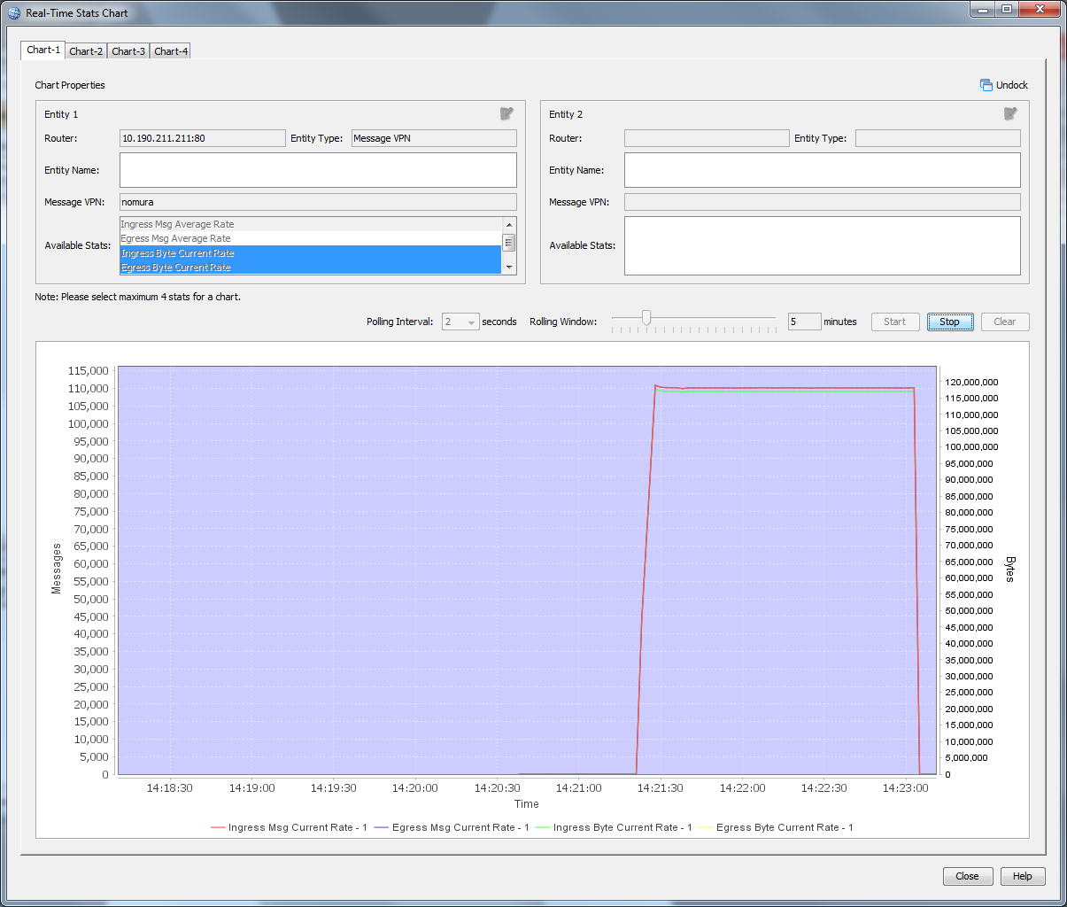

Latency Stats

./sdkperf_java.sh -cip=10.191.247.245 -ptl=test/gm/probe -cu=nomura-gu@nomura -cp=password -l -mn=10000 -mr=100 -mt=persistent -msa=1000

./sdkperf_java.sh -cip=10.191.247.245 -stl=test/gm/probe -cu=nomura-gu@nomura -cp=password -l -lat -lb=4096 -lwu=20 -tte=1 –q

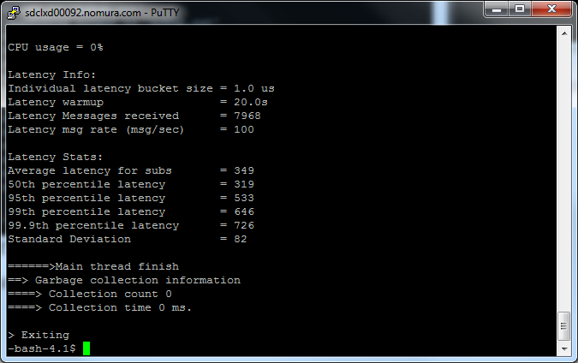

./pub__gm_througput.sh 10 2000 16500

./sub__gm__througput.sh 10

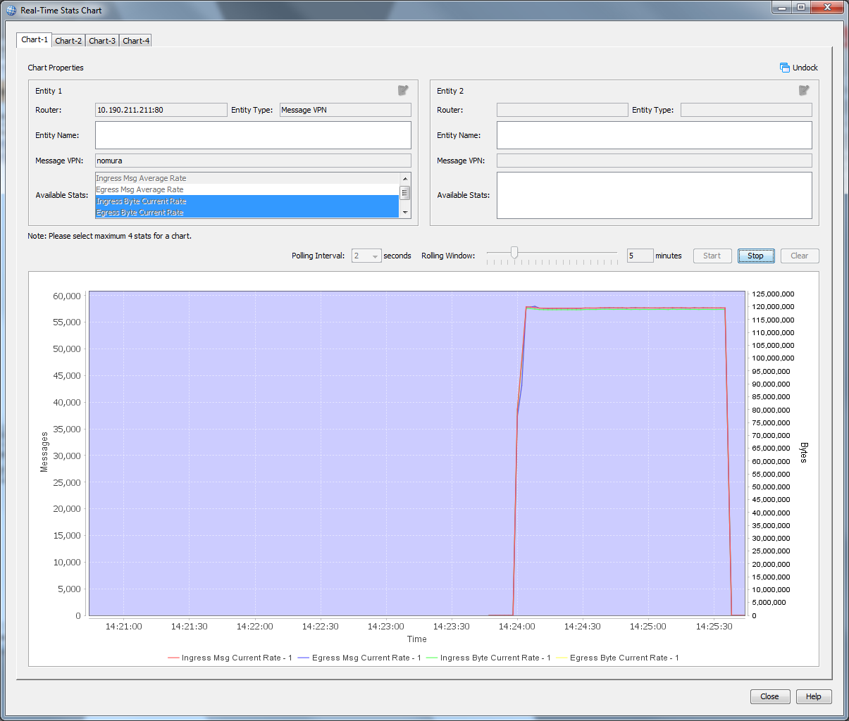

Latency Stats

./sdkperf_java.sh -cip=10.191.247.245 -ptl=test/gm/probe -cu=nomura-gu@nomura -cp=password -l -mn=10000 -mr=100 -mt=persistent -msa=2000

./sdkperf_java.sh -cip=10.191.247.245 -stl=test/gm/probe -cu=nomura-gu@nomura -cp=password -l -lat -lb=4096 -lwu=20 -tte=1 –q

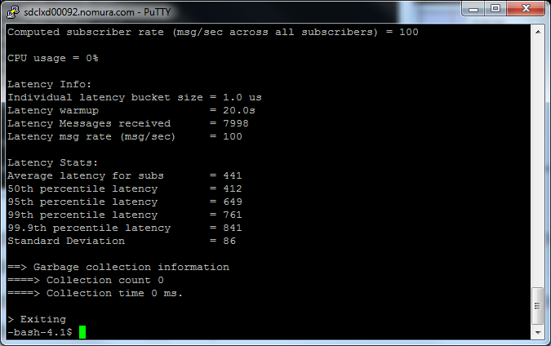

./pub__gm_througput.sh 10 5000 16500

./sub__gm__througput.sh 10

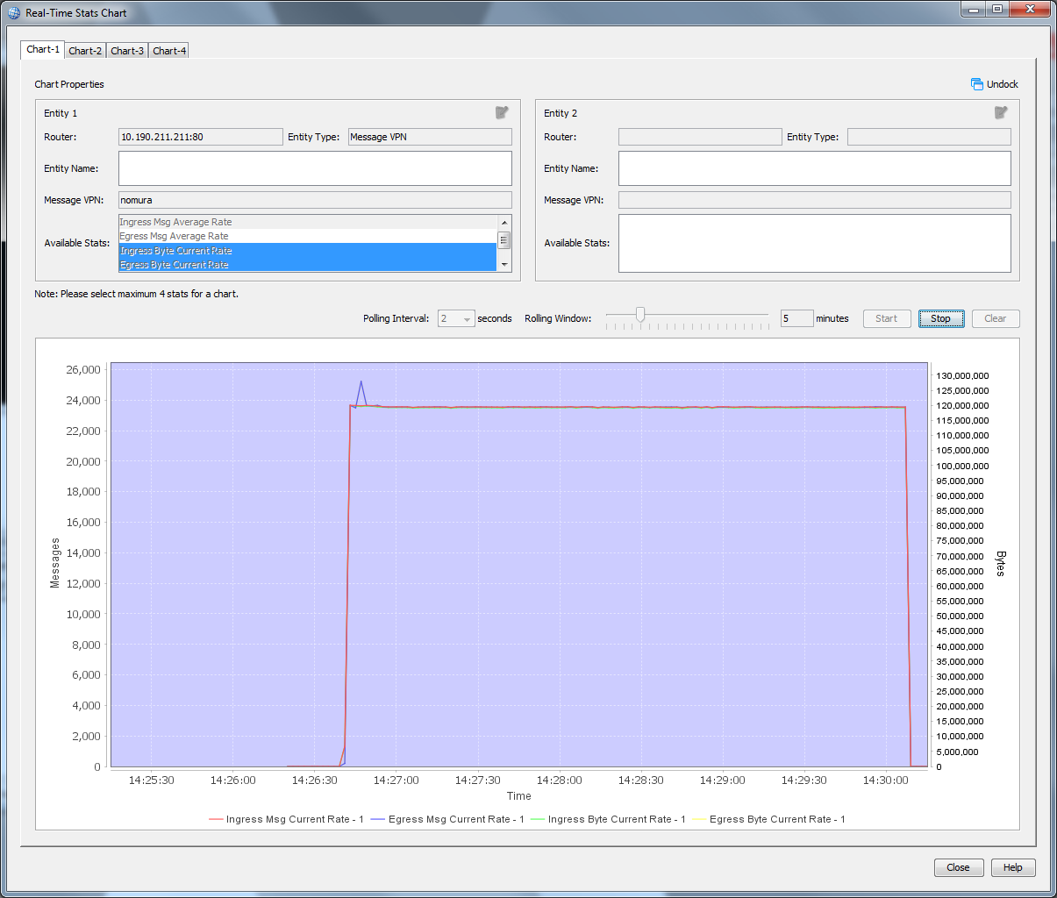

Latency Stats

./sdkperf_java.sh -cip=10.191.247.245 -ptl=test/gm/probe -cu=nomura-gu@nomura -cp=password -l -mn=10000 -mr=100 -mt=persistent -msa=5000

./sdkperf_java.sh -cip=10.191.247.245 -stl=test/gm/probe -cu=nomura-gu@nomura -cp=password -l -lat -lb=4096 -lwu=20 -tte=1 –q

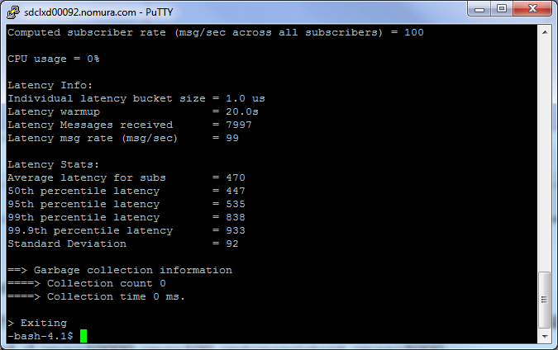

**Guaranteed messaging fanout tests.**

4.3.1

9k connections

taskset -c 16 ./sdkperf_java.sh -cip=10.191.247.245 -ptl=test/max/connections -mn=10000 -cc=9000 -mr=1 -cu=nomura-du@nomura -cp=password -psm -q

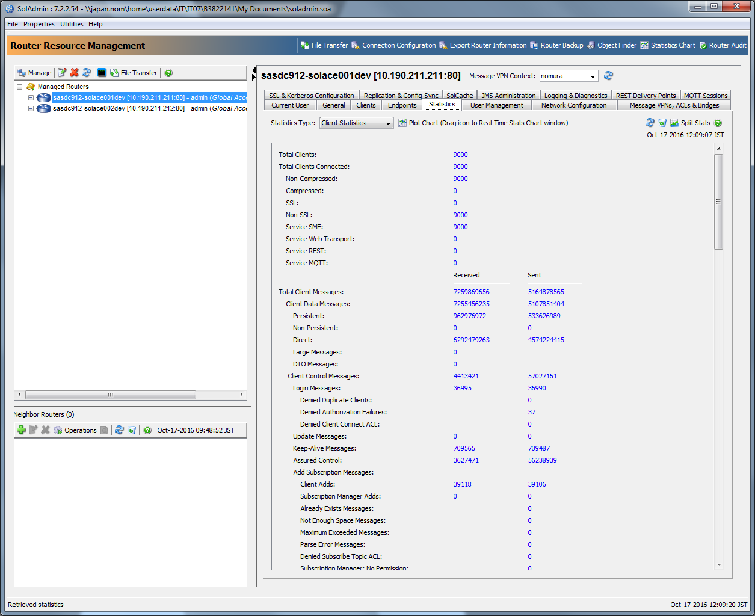

5M Unique Topics

./sdkperf_java.sh -cip=10.191.247.245 -stf=5MTopics.txt -cu=nomura-du@nomura -cp=password -q

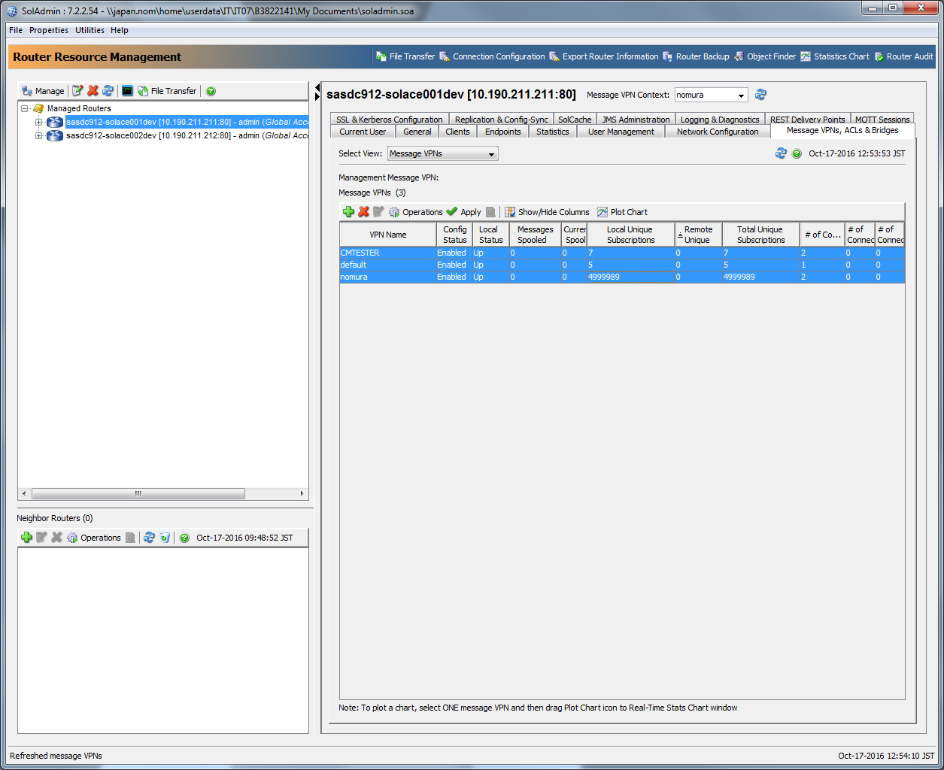

10 Million Aggregate Subs

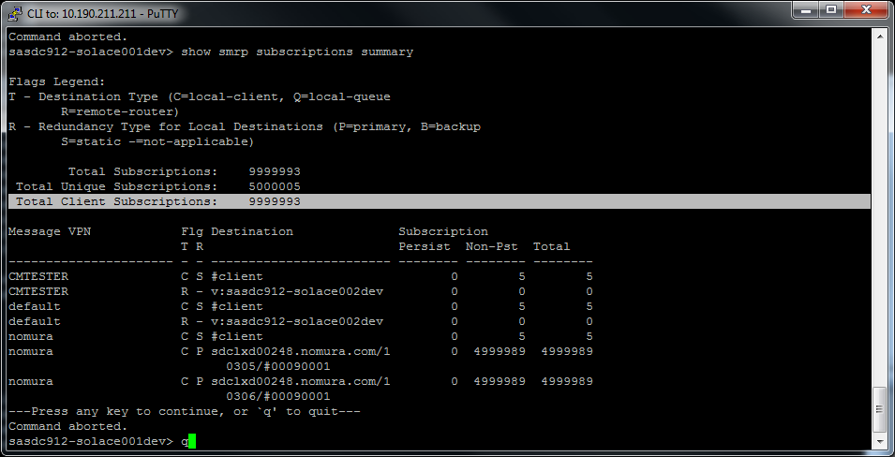

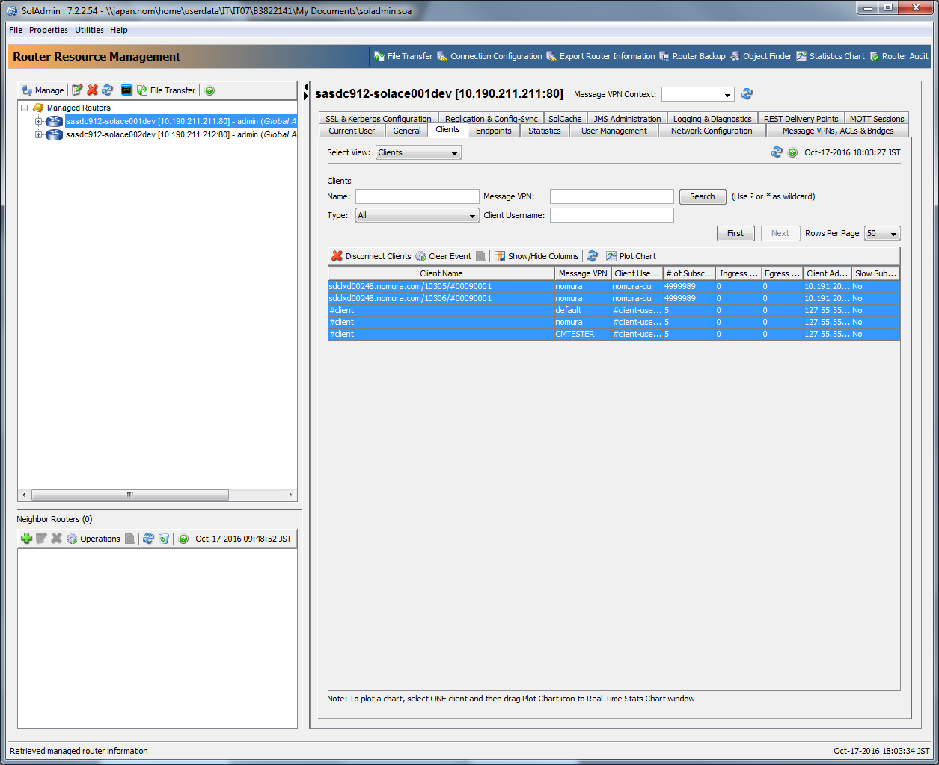

16k endpoints

./sdkperf_java.sh -cip=10.191.247.245 -tte=16000 -cu=nomura-gu@nomura -cp=password -stl=test/16k -ptl=test/16k -mt=persistent -mn=1000 -q

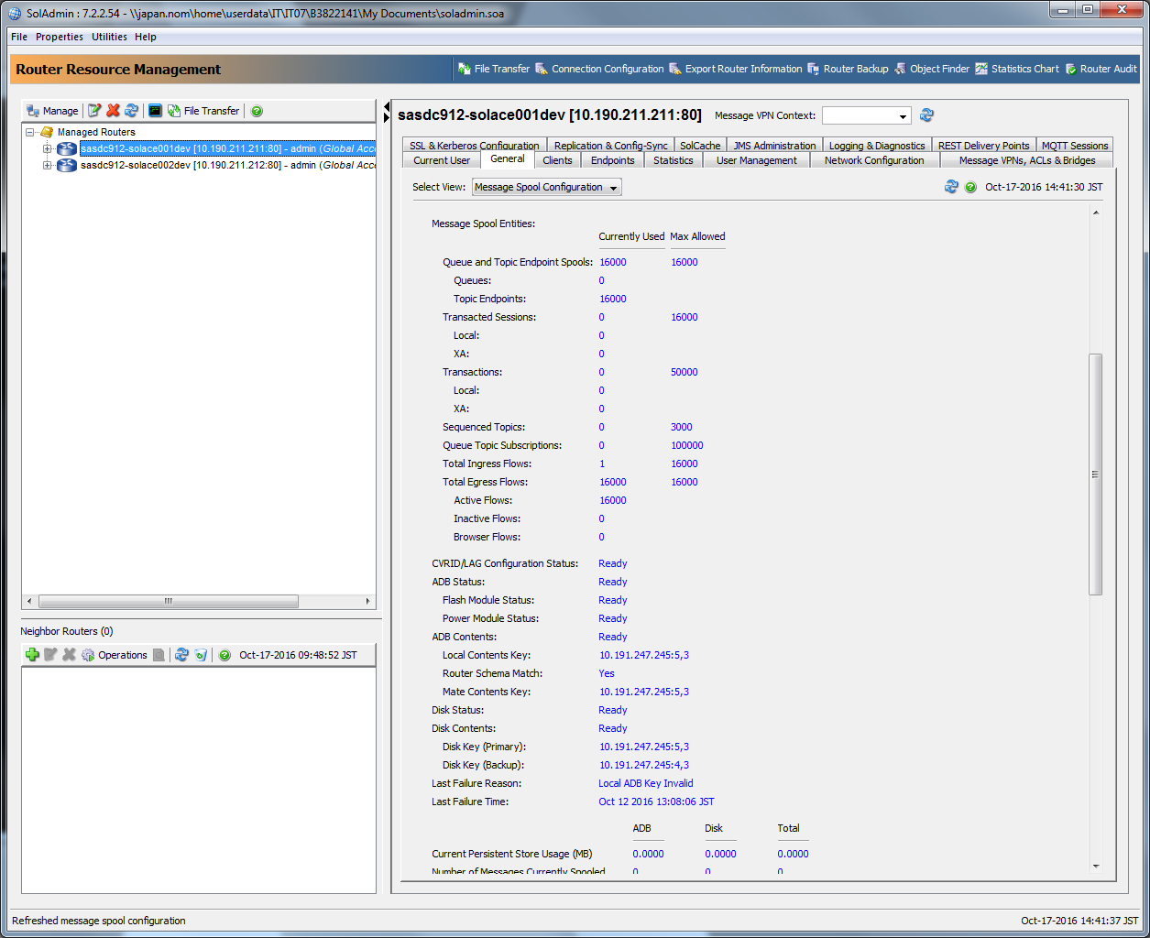

16k pub/sub/flows

Total Ingress (Pub) Flows

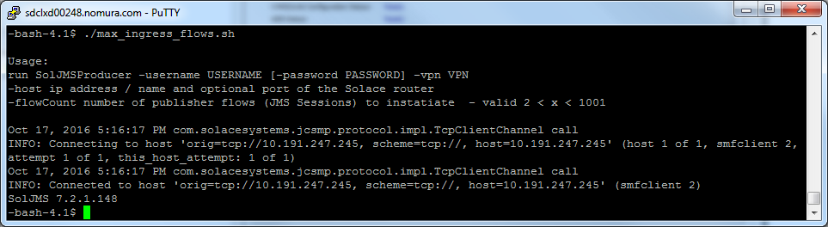

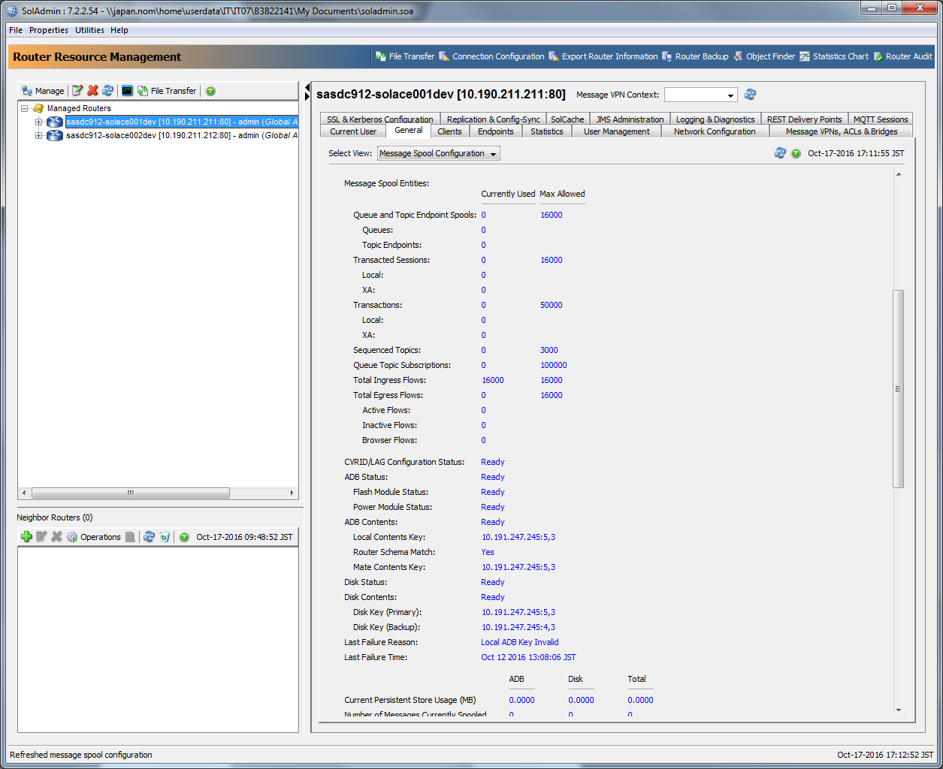

Total Egress (Sub) Flows

./sdkperf_java.sh -cip=10.191.247.245 -tte=16000 -cu=nomura-gu@nomura -cp=password -q

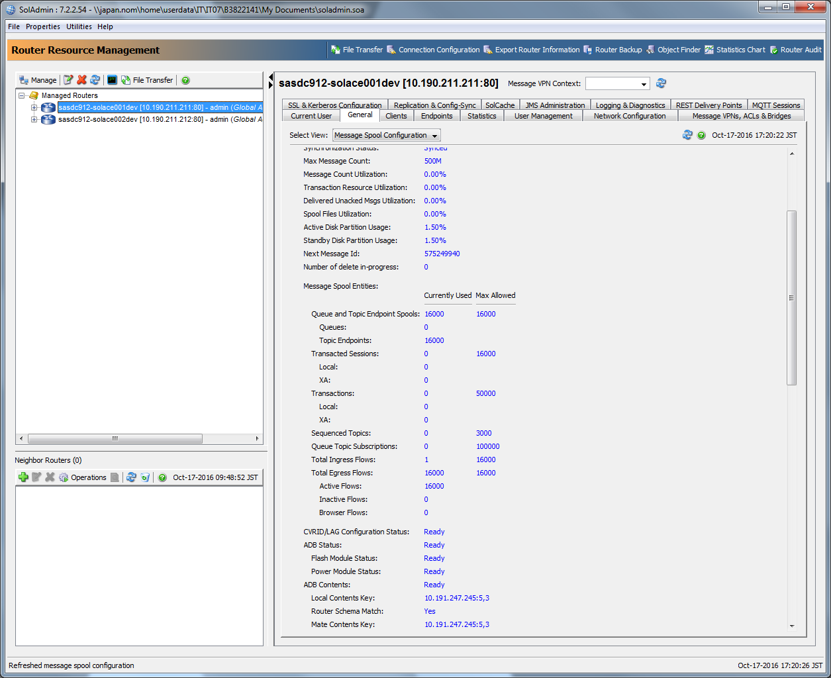

30 MB Max message Size

Success

./sdkperf_java.sh -cip=10.191.247.245 -cu=nomura-gu@nomura -cp=password -ptl=test/30Mb -mn=1 -mt=persistent -msa=30000000

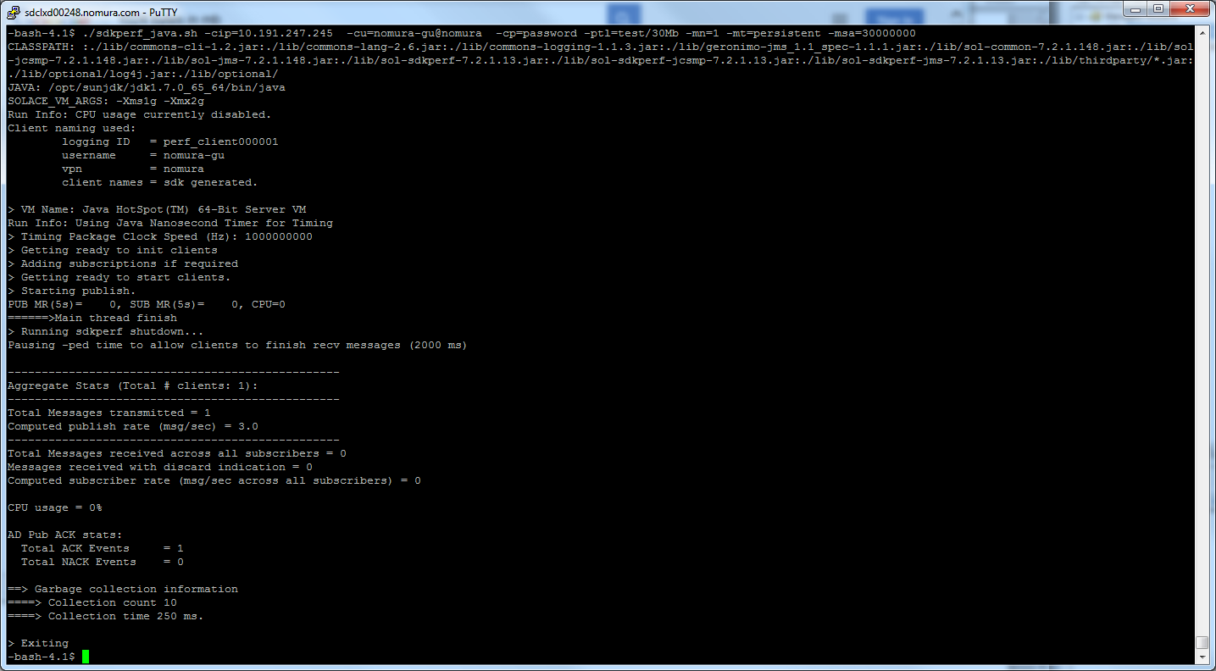

Failure

./sdkperf_java.sh -cip=10.191.247.245 -cu=nomura-gu@nomura -cp=password -ptl=test/30Mb -mn=1 -mt=persistent -msa=31000000

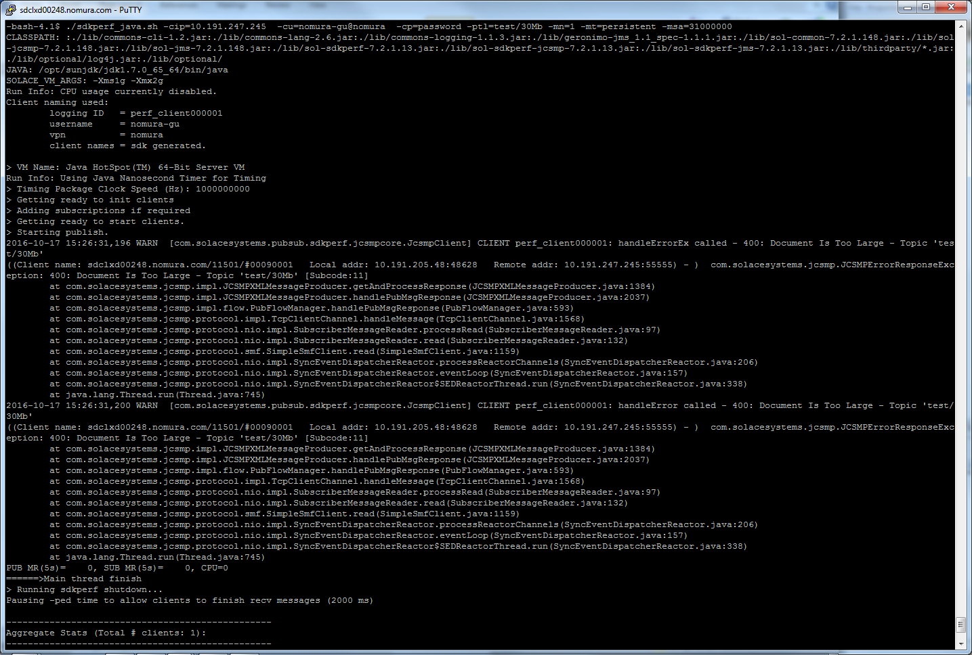

64 MB Max size for direct message

Success

./sdkperf_java.sh -cip=10.191.247.245 -cu=nomura-gu@nomura -cp=password -ptl=test/30Mb -mn=1 -msa=64000000

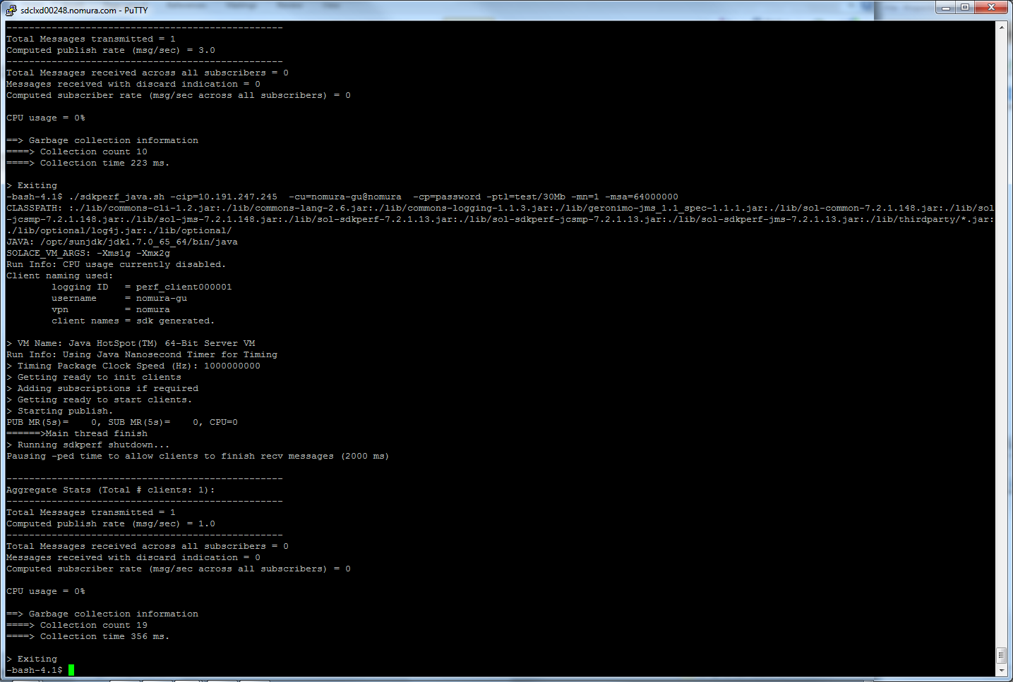

Failure

./sdkperf_java.sh -cip=10.191.247.245 -cu=nomura-gu@nomura -cp=password -ptl=test/30Mb -mn=1 -msa=70000000

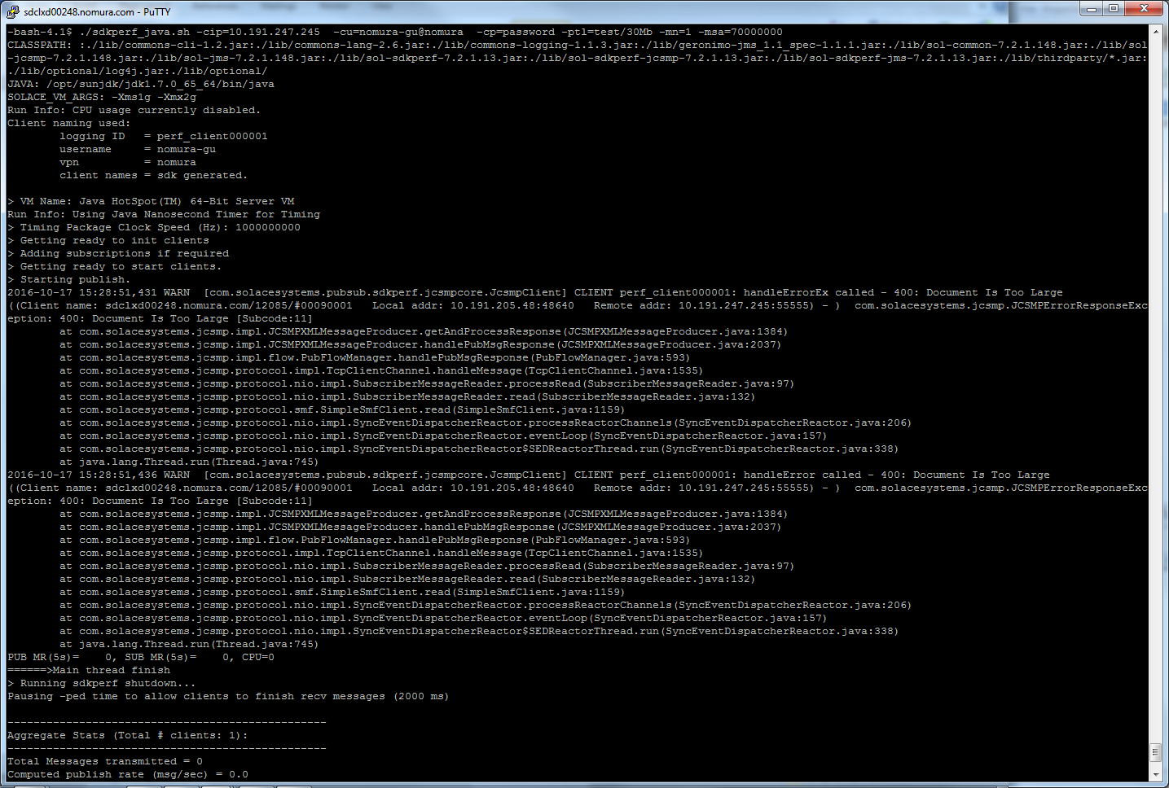

Failover/Failback – Graceful

